Lab Notebook of T.Perez | CSUN 108484650 | COMP490L | CTL-DYnAmiCs

10-4-18

Spoke with prof Shapiro re informal mentoring of project, and said he’ll email prof Dewey.

[Mentioned to prof Dewey about the above. ]

12-25-18 - **Addendum**; The email ever happened. Professor

Dewey is my official advisor since he has extensive experience in bioinformatics, luckily,

anyway. Professor Shapiro is still happy to be my unofficial advisor.

It was suggested by prof S that a glossary might be helpful if needed on paper.

“Venue” was discussed. The math’ venue was chosen. * 12-25-18 – **Addendum;** A computer

science venue makes more dense. It happens to be a computational biology related research

project however.

* Since this is the case now, a toned-down version of the Contributions page should be

re-written. 12-25-18 – **Addendum;**  The latter is complete.

10-5-18

Sent prof D and prof S ;

https://github.com/citationdude/NK-Cell-Simulator link

10-6-18

A toned-down version of the Contributions page was resubmitted. It also was probably an unacceptable format since it included an abstraction of the paper’s future abstract to sort of

“guide in” a pathway (an exposition to the “storyline”) to a somewhat new concept to those whom may review the paper.

10-7-18

**Plan of execution** for reviving and amending older model ‡ ; ; ;

Review prior notes.

Re-read Killer Cell Dyn – Wodarz ‡

10-8-18

LTG (long term goal) graphic;

Conceptual

correlations

Review all Hao Yuan Kueh material

Review

all Wodarz material

WODARZ-KUEH CORRELATION MDL

Mathematical

correlations

Current (10-8-18)

Wodarz mdl.

(Get Qt Creator version working)

Staged Wodarz model

Staged Kueh model

Get solutions via ODE tool (recommended by Prof Shapiro)

Determine Kueh

variables. Using Wodarz dynamic equations*. Setup*.

Implement o/p metrics

Test both versions

10-9-18 [ADD to Paper/ Introduction - TBA]

It must be considered that there exists certain mechanisms that are not included for this research. A relatively important one is transcriptase in terms of it’s proofreading type capabilities.

Since the Wodarz model is LCMV virus based, (key word virus), and his experiments are CD4 centered, many or most viruses are CD4 impaired , as are many cancers. Regarding CD4/CTL, there can be a valid correlation between certain cancers and certain viruses like LCMV. It just happens that the mouse virus (LCMV) is a good model. A well known virus of course the the HIV virus. Here, like cancers being of the retrovirus type, HIV is also a transcriptase problem (reverse transcriptase mechanism). [Wodarz 2007]. Also behaving differently from each other, in terms of immunology, the HIV and HCV are CD4 problematic.

New new discovery has been published regarding this, (ie the concept of [basically] way too many variables that can possibly determine viral or cancerous efficacy). As reported by the Cancer research UK, [cited by James Gallagher – Health and Science correspondent, BBC News – 12, Apr 2018], [sic]the Francis Crick Institute developed a way to analyze a cancer’s history to predict its future. One cancer could kill quickly while a patient with a seemingly identical cancer could live for decades after treatment. They state that [and knowing that , sic] as cancers grow and evolve, they become more mutated and, eventually, different parts of the tumor start to mutate in different ways.

ie to say, this phenomenon is so prevalent, they are intent on pinning down the root causes for this occurance.

10-12-18

OSX upgraded from 10.10.5 to High Sierra 10.13.6 by Dino Computers. This allows ;

• IDE Qt Creator CTL_Dyn_5 to work. (∞)

• Parallels to be upgraded.

• ((MS Virtual Studio with Q# (quantum sim’ library) to work for OSX. ))

(∞) The initial runtime Wodarz pathway GUI is now used. Metrics also now output upon

successful pgm termination.

10-13-18 [ADD to Paper/ 1st ¶ of Introduction – TBA (re validation of LCMV Wodarz §7.2 p103)]

[sic]”LCMV infection is an ideal system to test mathematical predictions. The occurance of CTL-induced pathology resulting from the killing of infected cells is clearly documented with LCMV. In addition, viral and host parameters can be carried easily.”

[Wodarz p100]Several or many concepts are under debate among researchers eg virus vs CTL contributions to tissue damage in the common cold, also eg, [Wodarz p155[Levy]]the mechanism at which CAF (CTL secreted antiviral factor) stops viral production of viral particles by host cells in HIV.

Added to this, are other nuances of immunity, eg, [Wodarz p125[Arnaout/Nowak 2000]] B-cells competition with CTL proliferations.

The point is that even if (by some miracle) this paper can be construed as somewhat useful beyond simply graphically depicting Wodarz-Kueh dynamics, it will be debated at best. (I will then take this as a compliment).

Careful with §7 (p99->) Control Virus CTL-Induced Pathology.

[Written lab’ notes below]

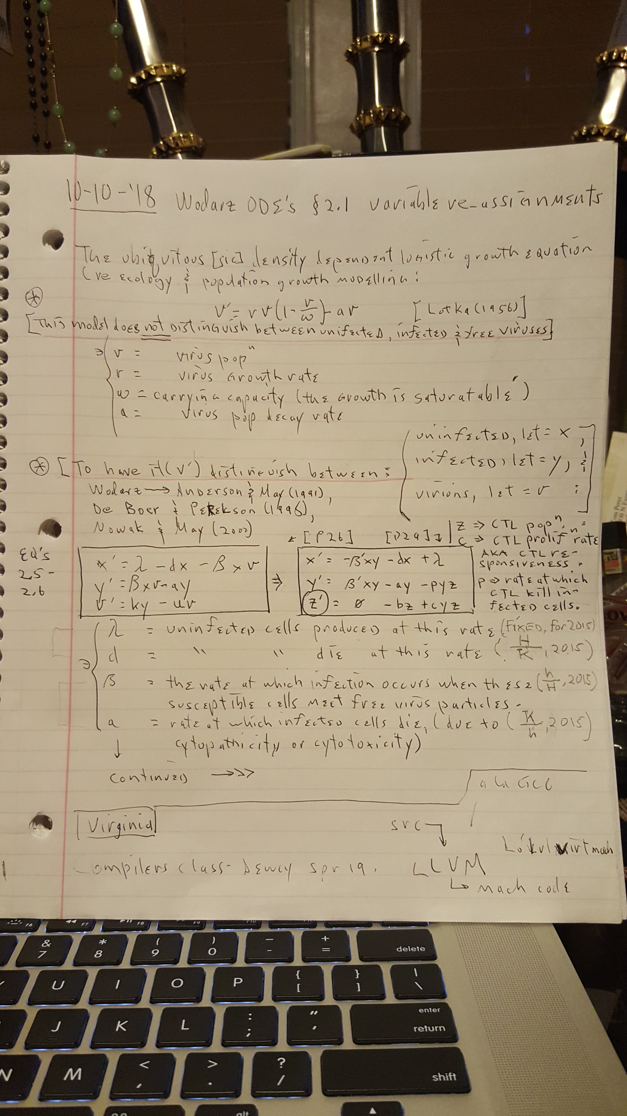

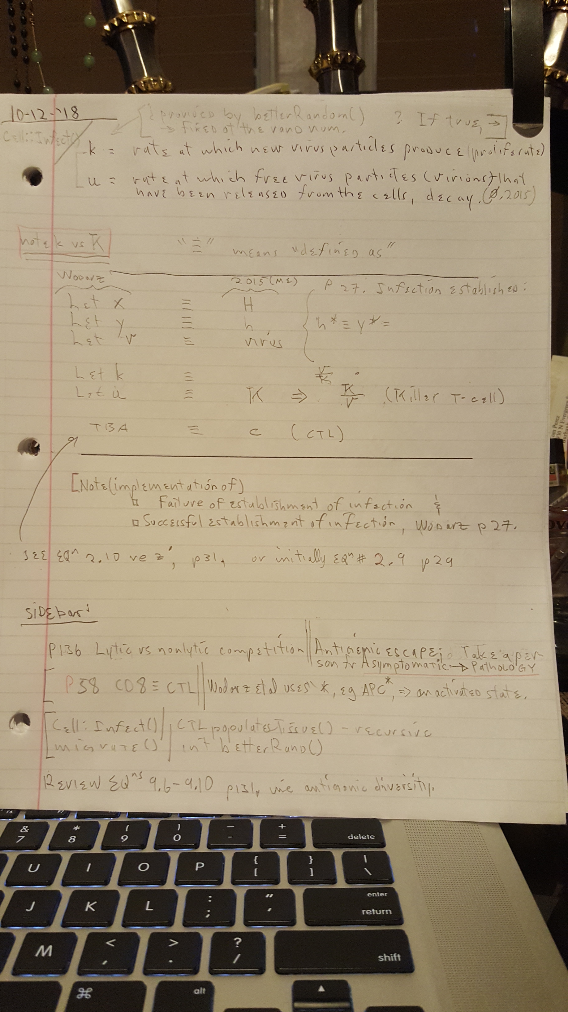

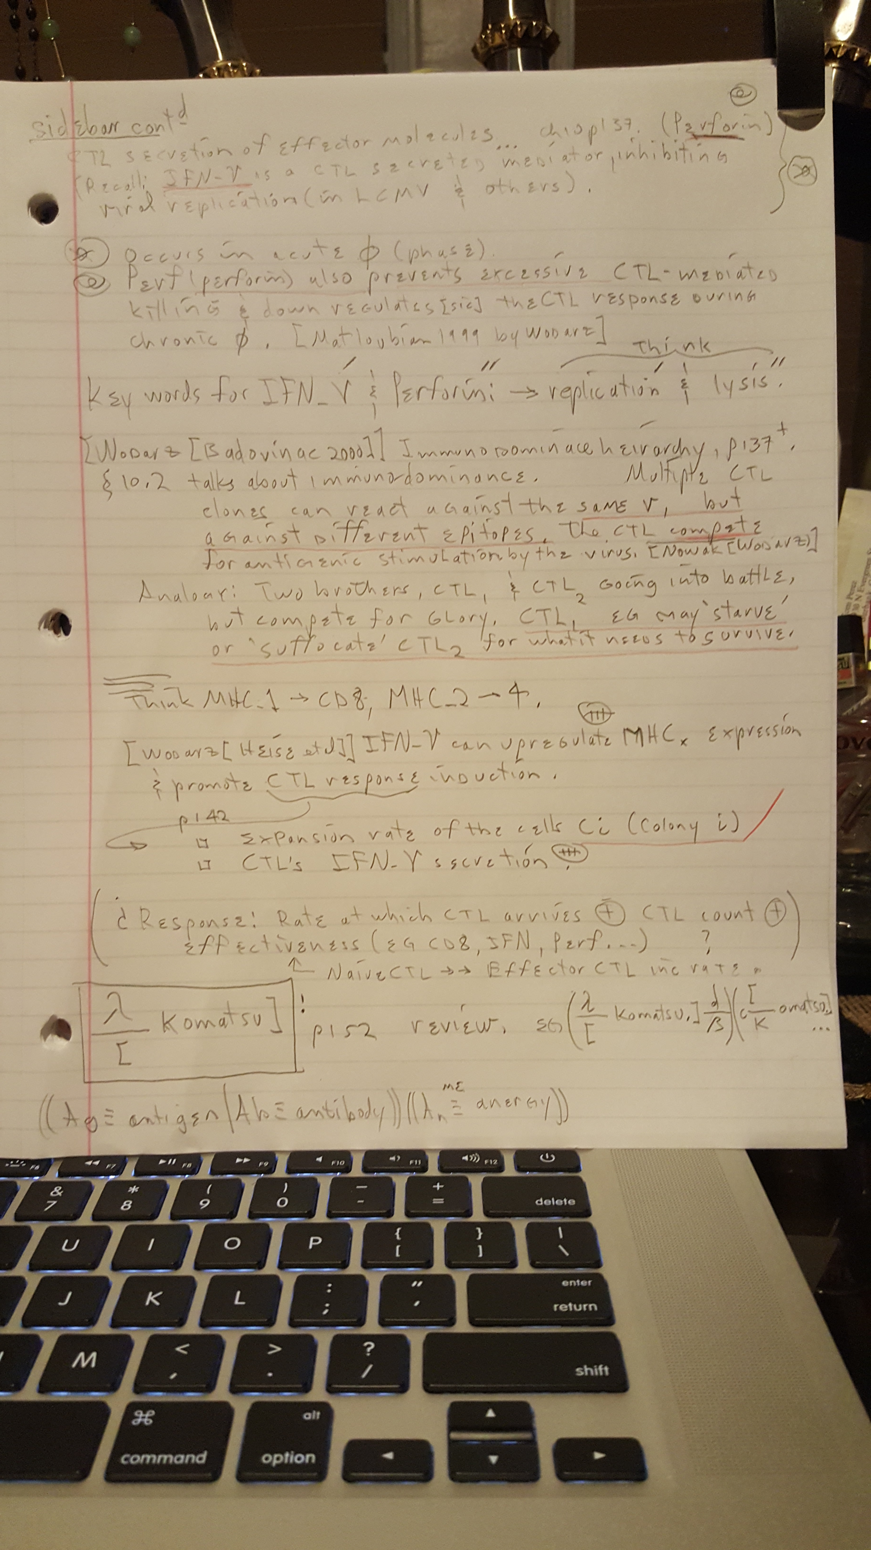

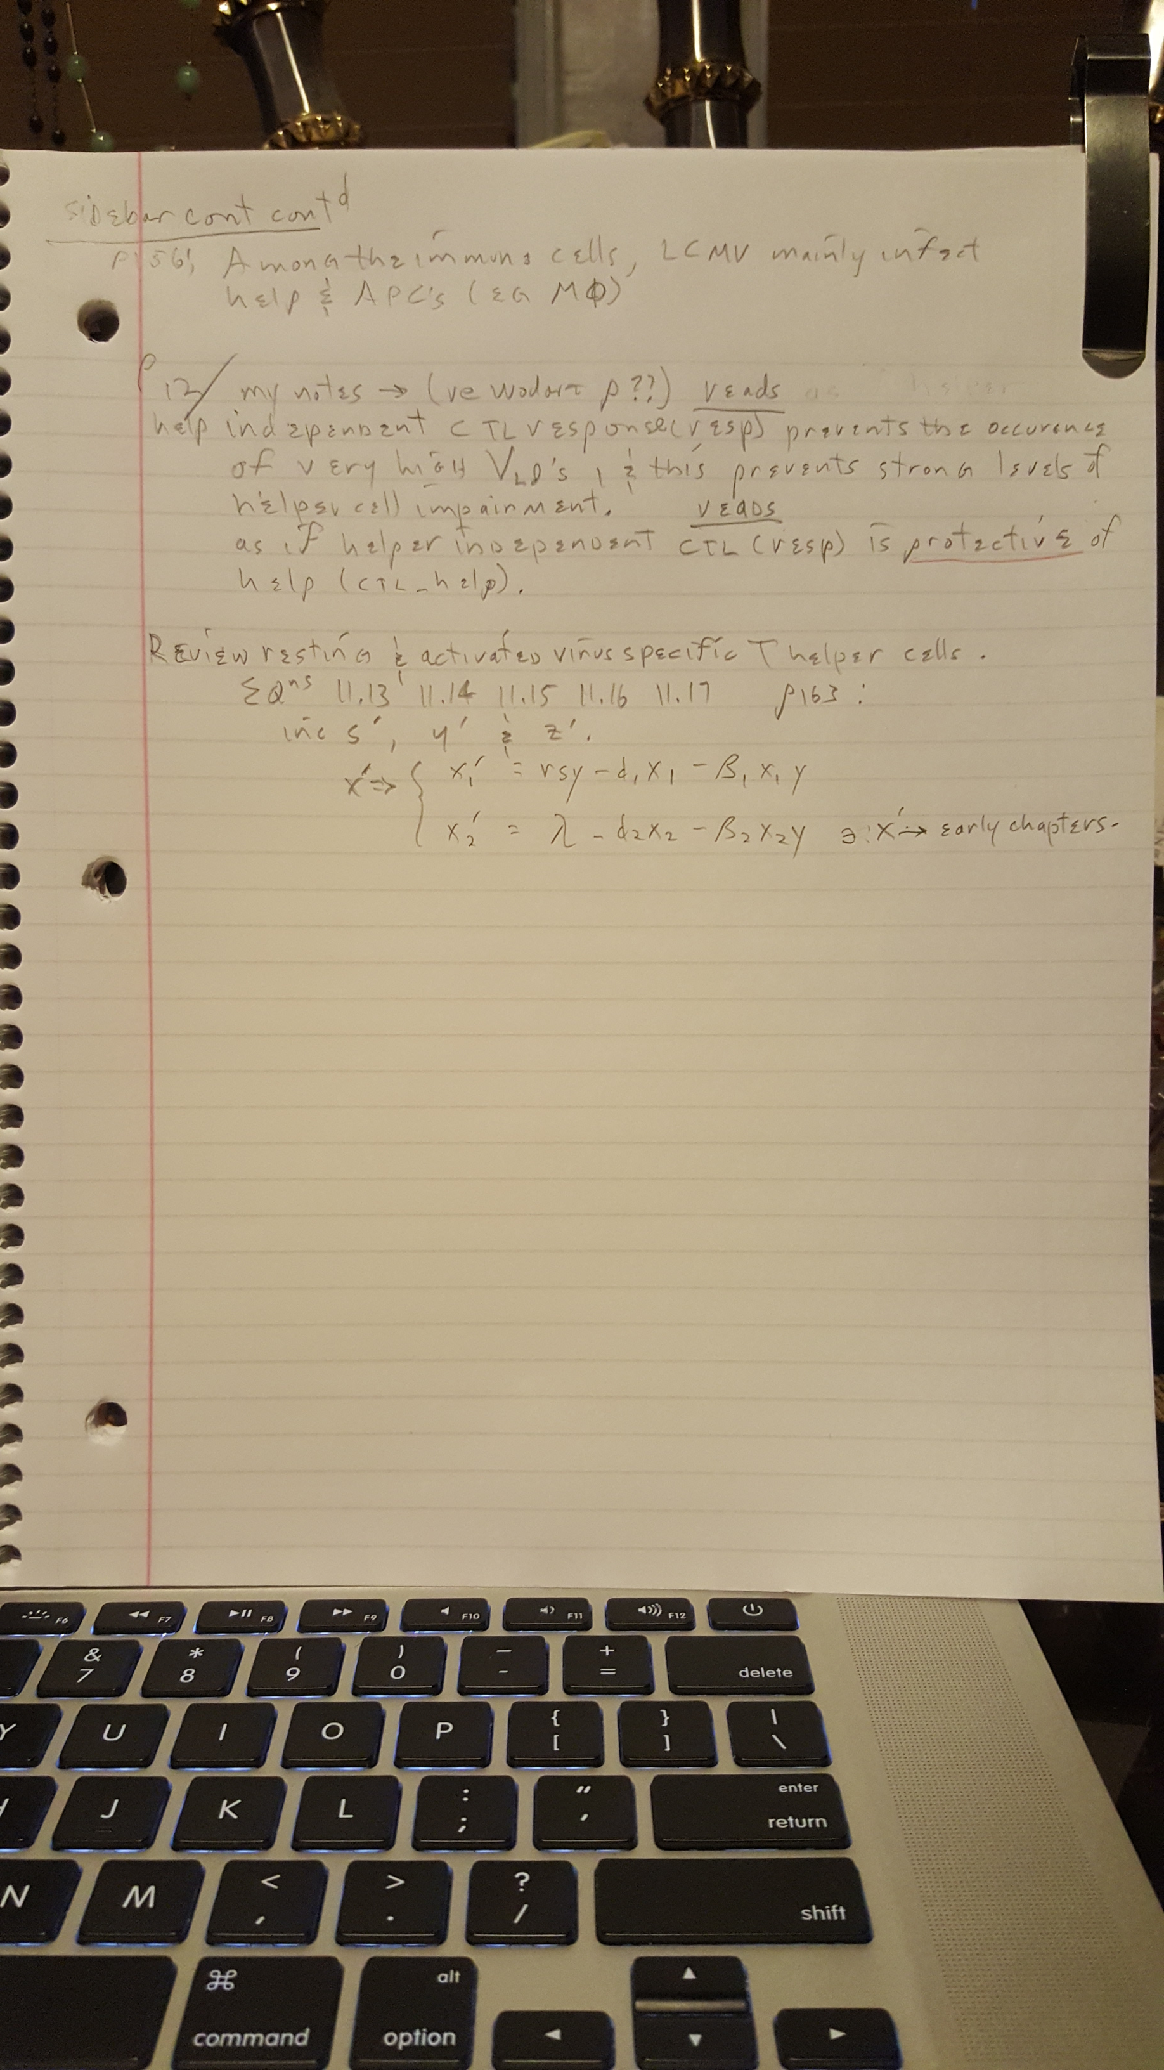

10-18-18

An enhanced awareness of the above Plan of Execution’s LTG (long term goal) graphic

is established.

Therefore the IMMEDIATE plan is to;

1) “Intelligently scan” the remaining portion of Wodarz. (Notes and summary completed).

A) Observe any dyn’ equations* that may be able to link or help link Wodarz to Kueh.

B) re Caltech Research Posting , investigate Kueh team member Kenneth Ng (Cal Poly’)

for any help*.

Search ResearchGate.

2) Read Dr. Kueh’s \*\***Asynchronous Combinatorial Action of Four Regulatory Factors Activates**

**BCL11b for T Cell Commitment,** (&/or Kenneth Ng’s work).

[Note] Caltech Research Posting 7-15-16 differs in flow of the 4 PT’s (protein) wrt Bcl11b from what Kueh’s paper** describes.

3)

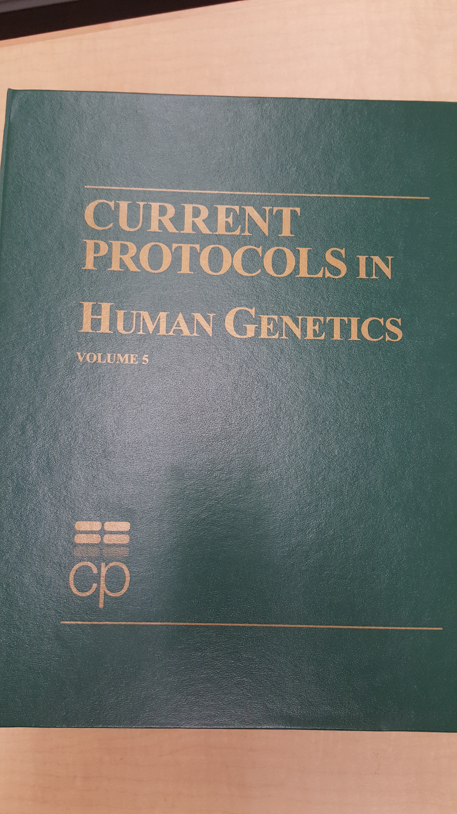

“Read” over sections 1 and 10.

[For what ever reason, this 5th volume was on the 1st floor as opposed to the 4th floor where the remaining volumes reside – see Gallery]

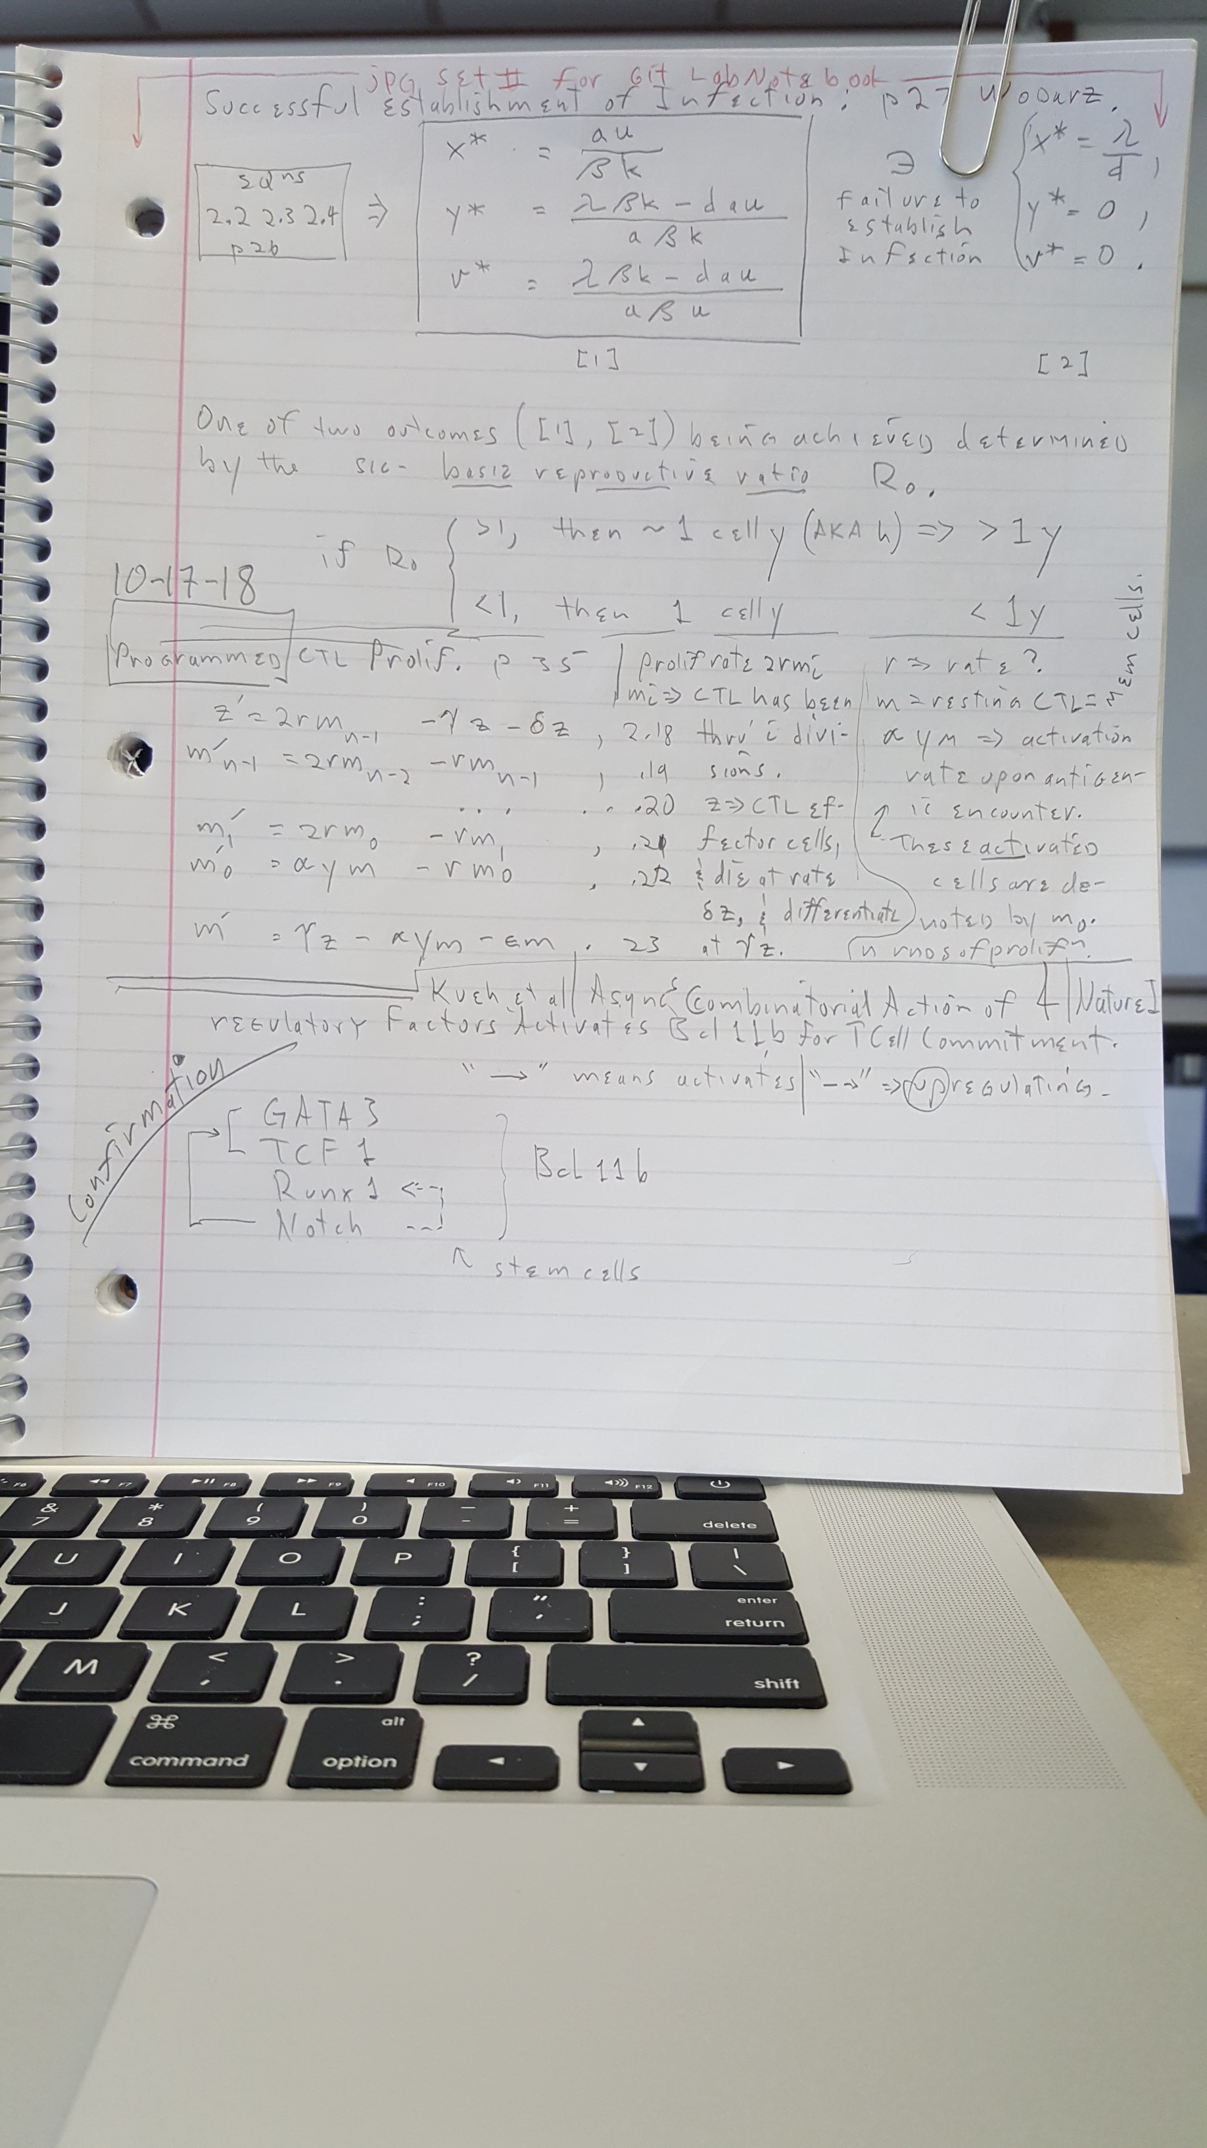

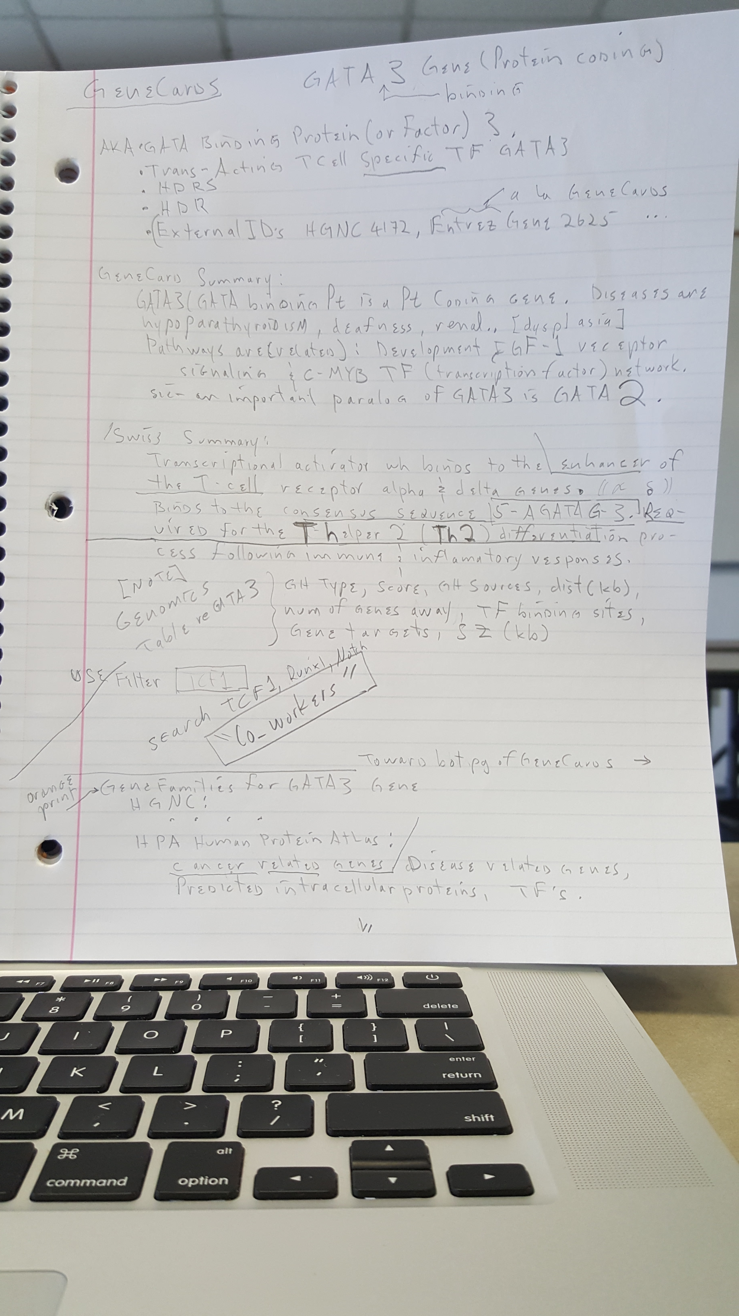

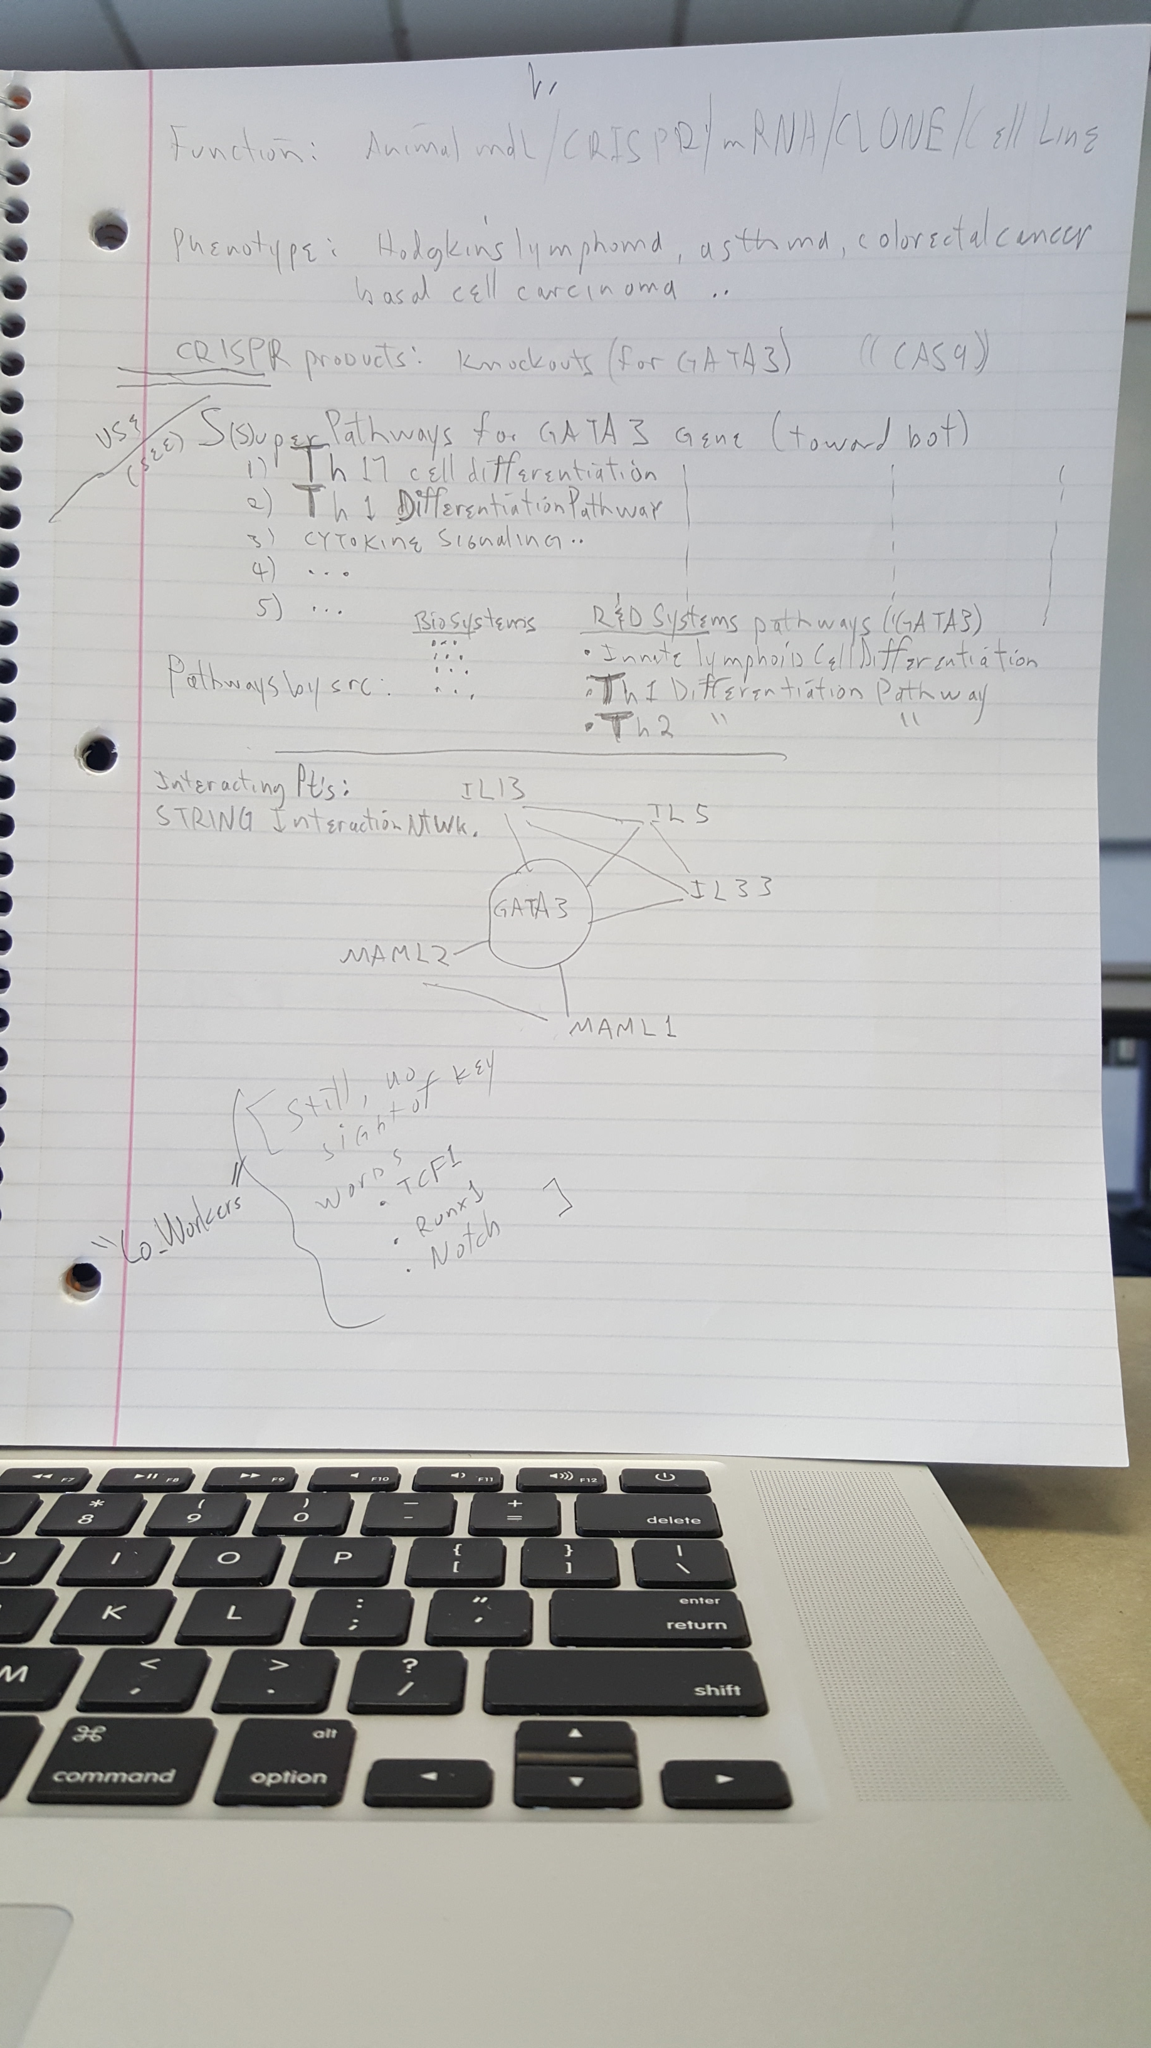

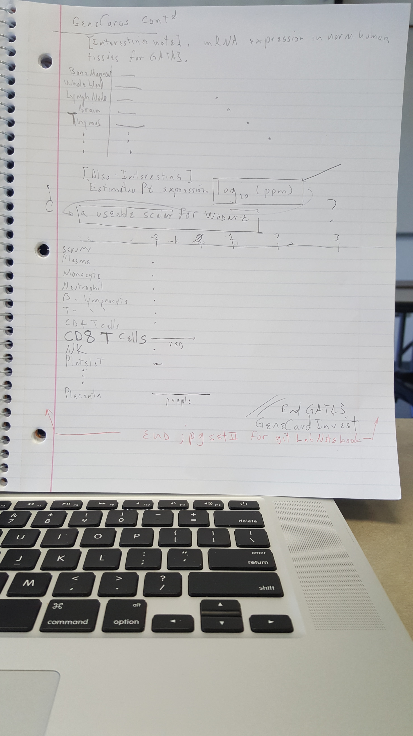

[end 10-18-18 log]

Mon 10-22-18

After reviewing Genetic Protocols, there are no dynamical like I see so far re any (hard information ) of the Kueh proteins except maybe under heading Gene Amplification in Tumors and APC mutation

but this is re polyposis. There may be some help under the heading Analysis of Gene Rearrangements, but …

Sun 11-4-18 (DST change day)

QT Creator with initial GUI complete.

Reviewing more on immunology [viz]re this paper.

(<) Spoke with prof Dewey and Shapiro re implementation of non-hard-mathematical Keuh model into CTL_dyn_5 as it stands currently, (sans any Kueh concepts yet).

Preparing for presentation in a few days. ~28sec / slide. So far, 14 slides.

11-7-18

Presentation complete.

11-11-18

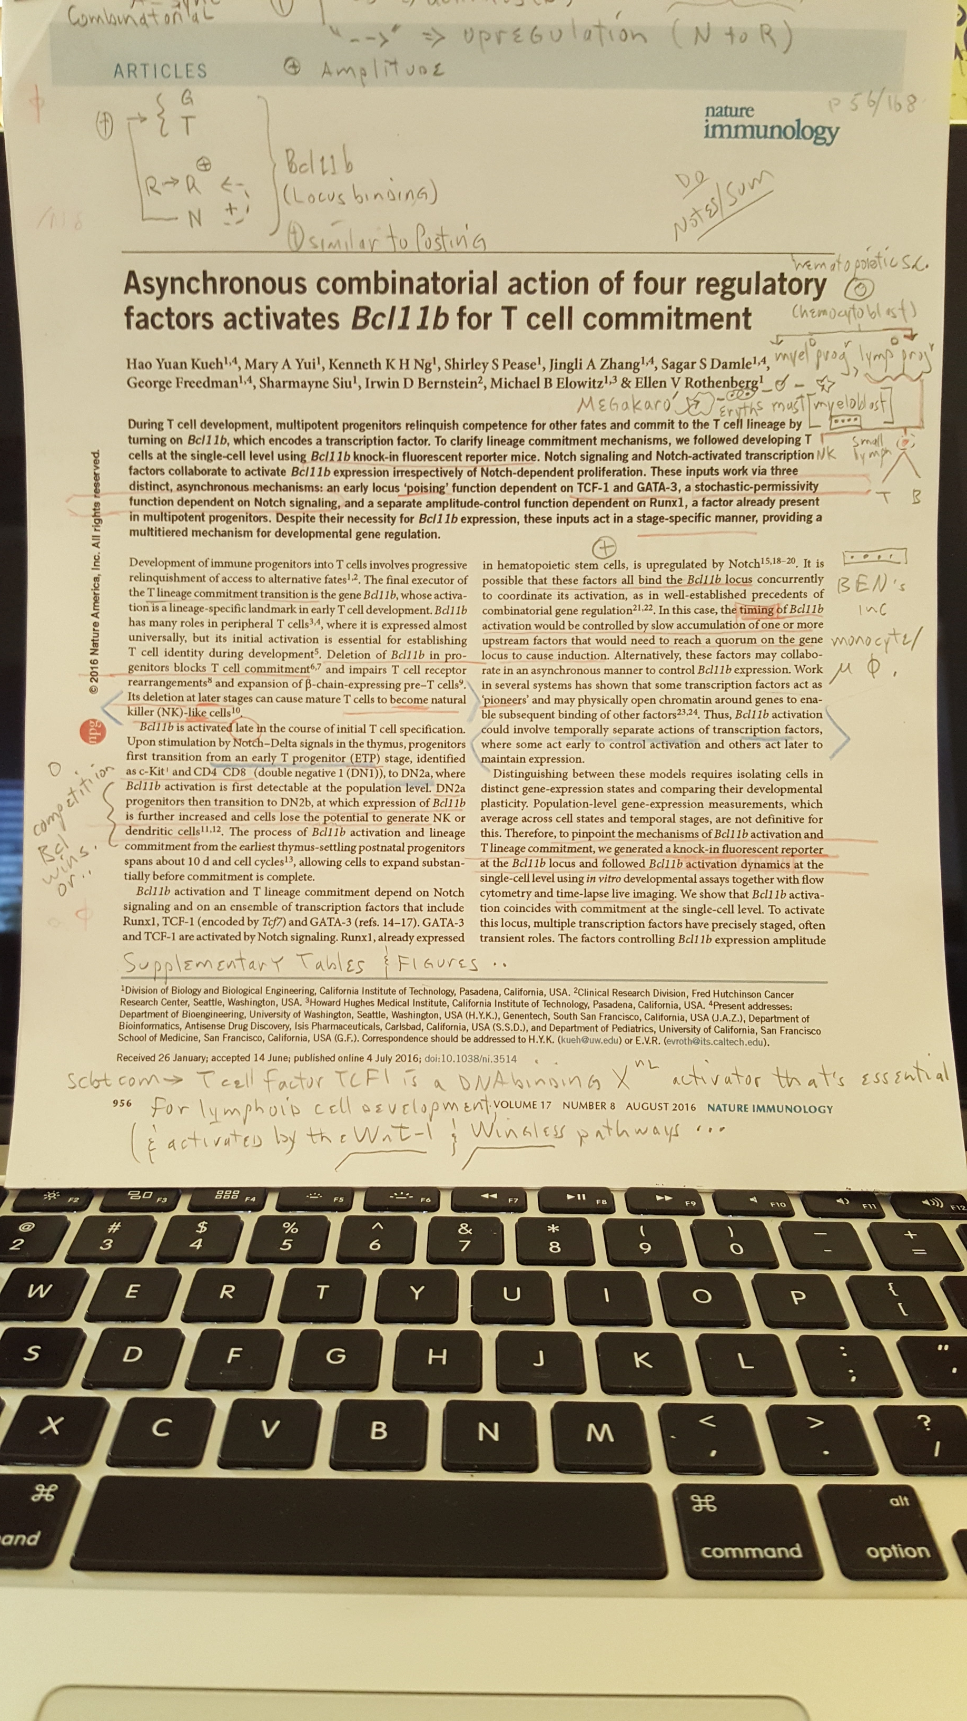

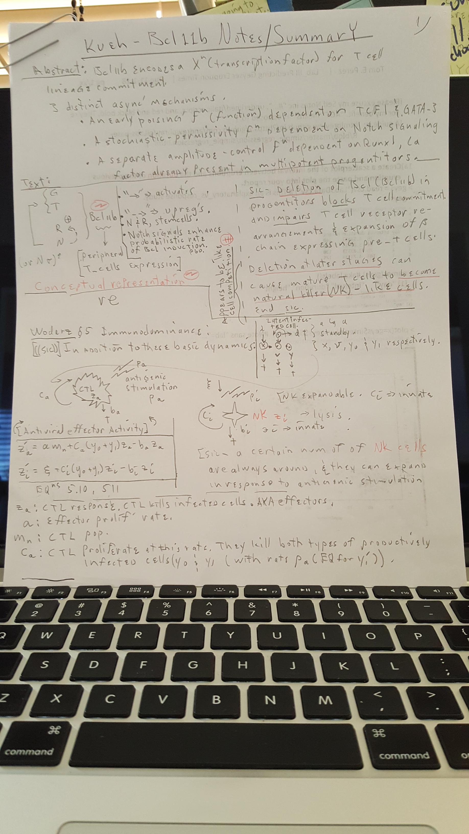

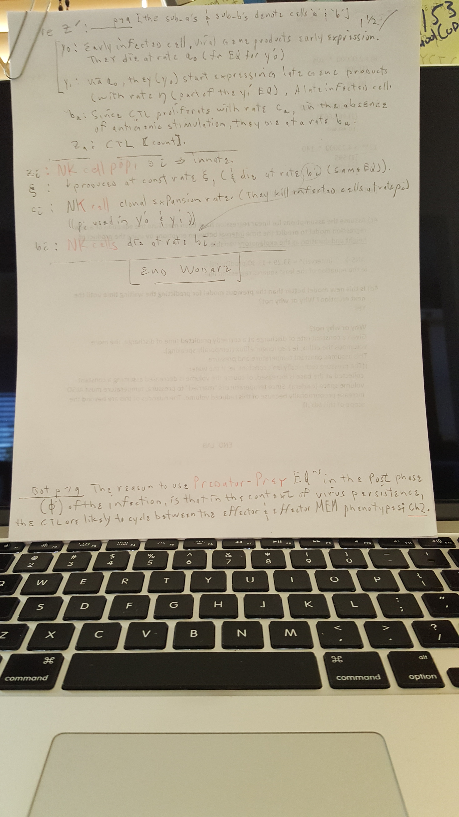

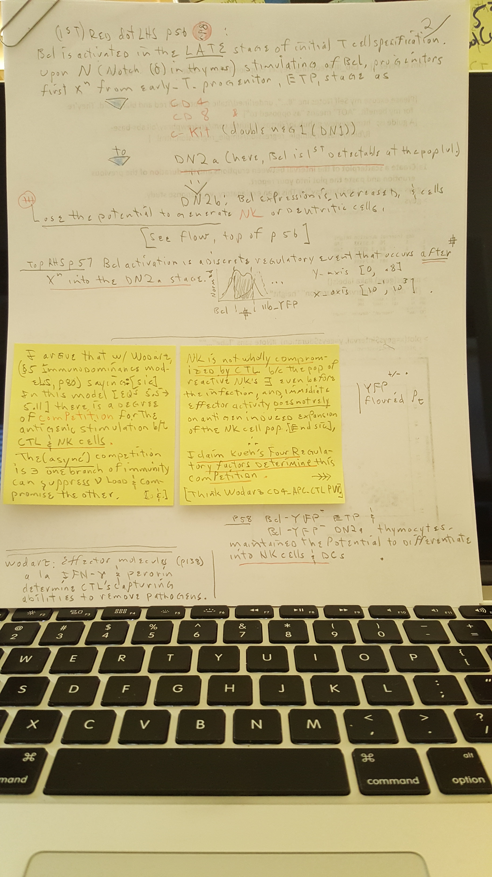

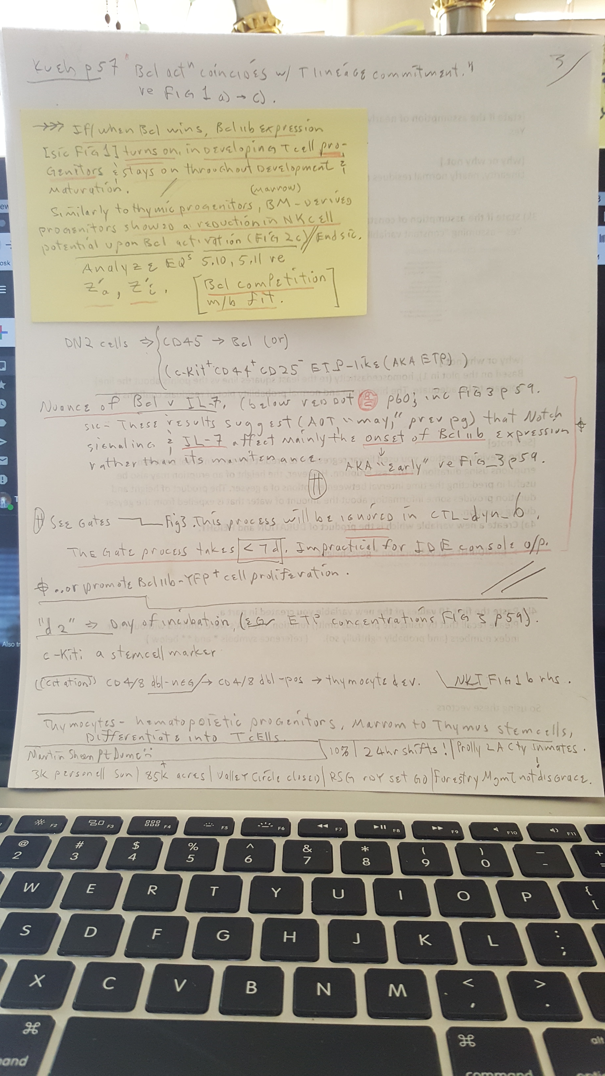

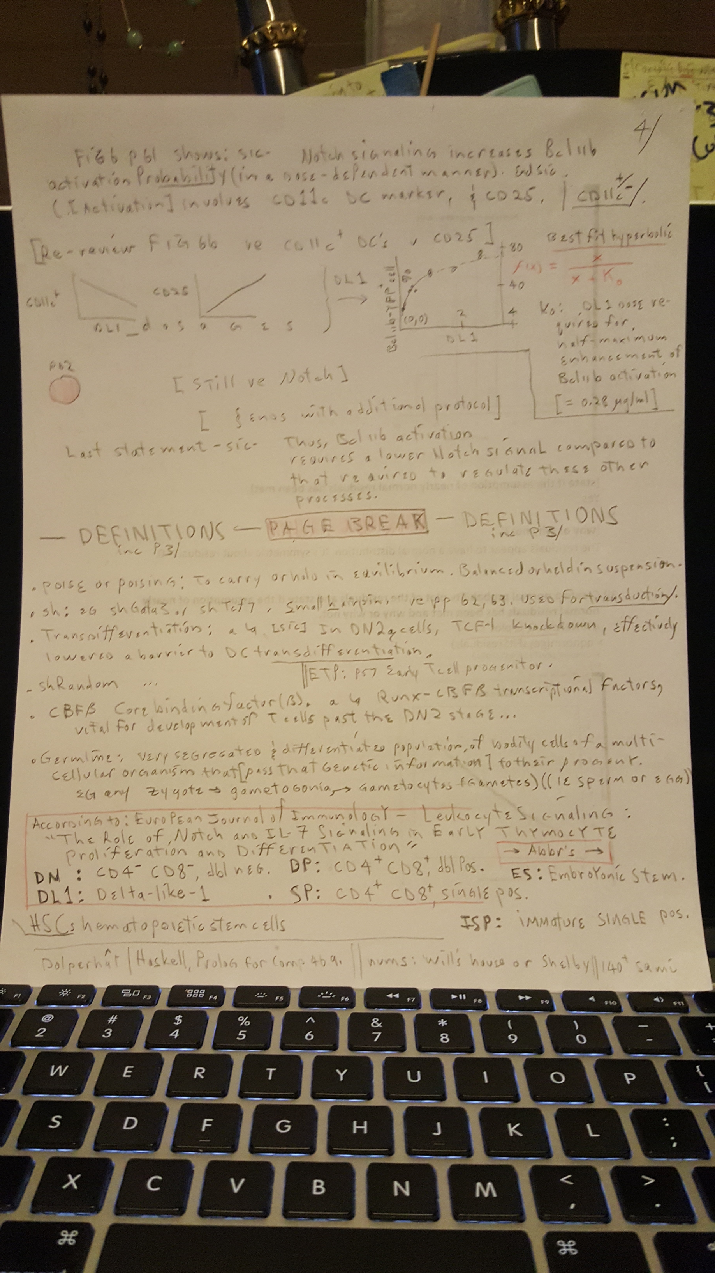

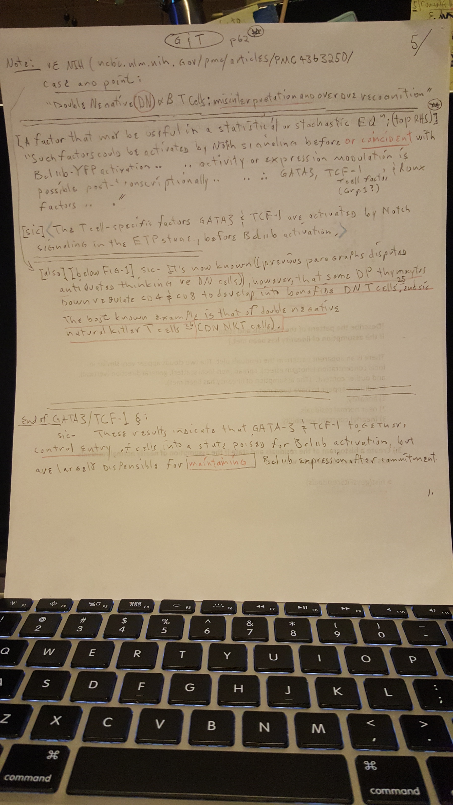

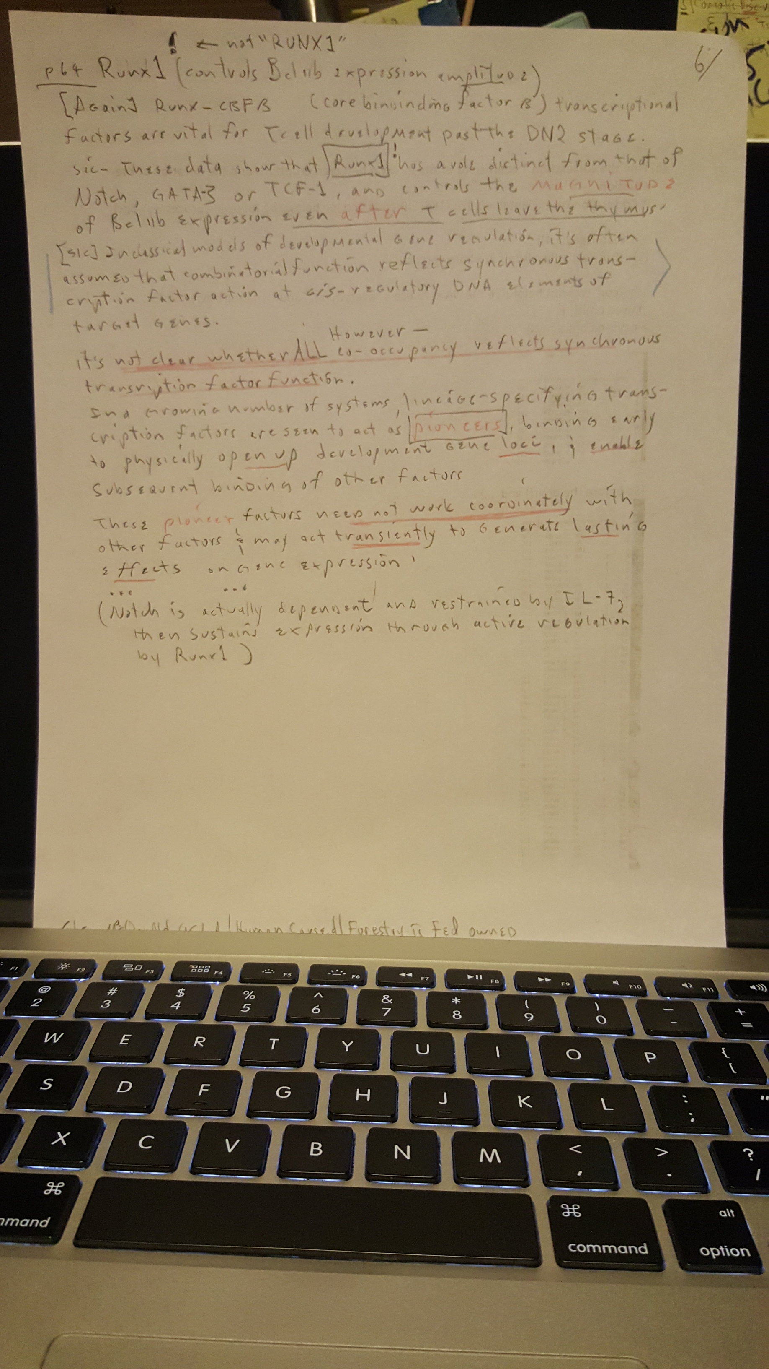

x

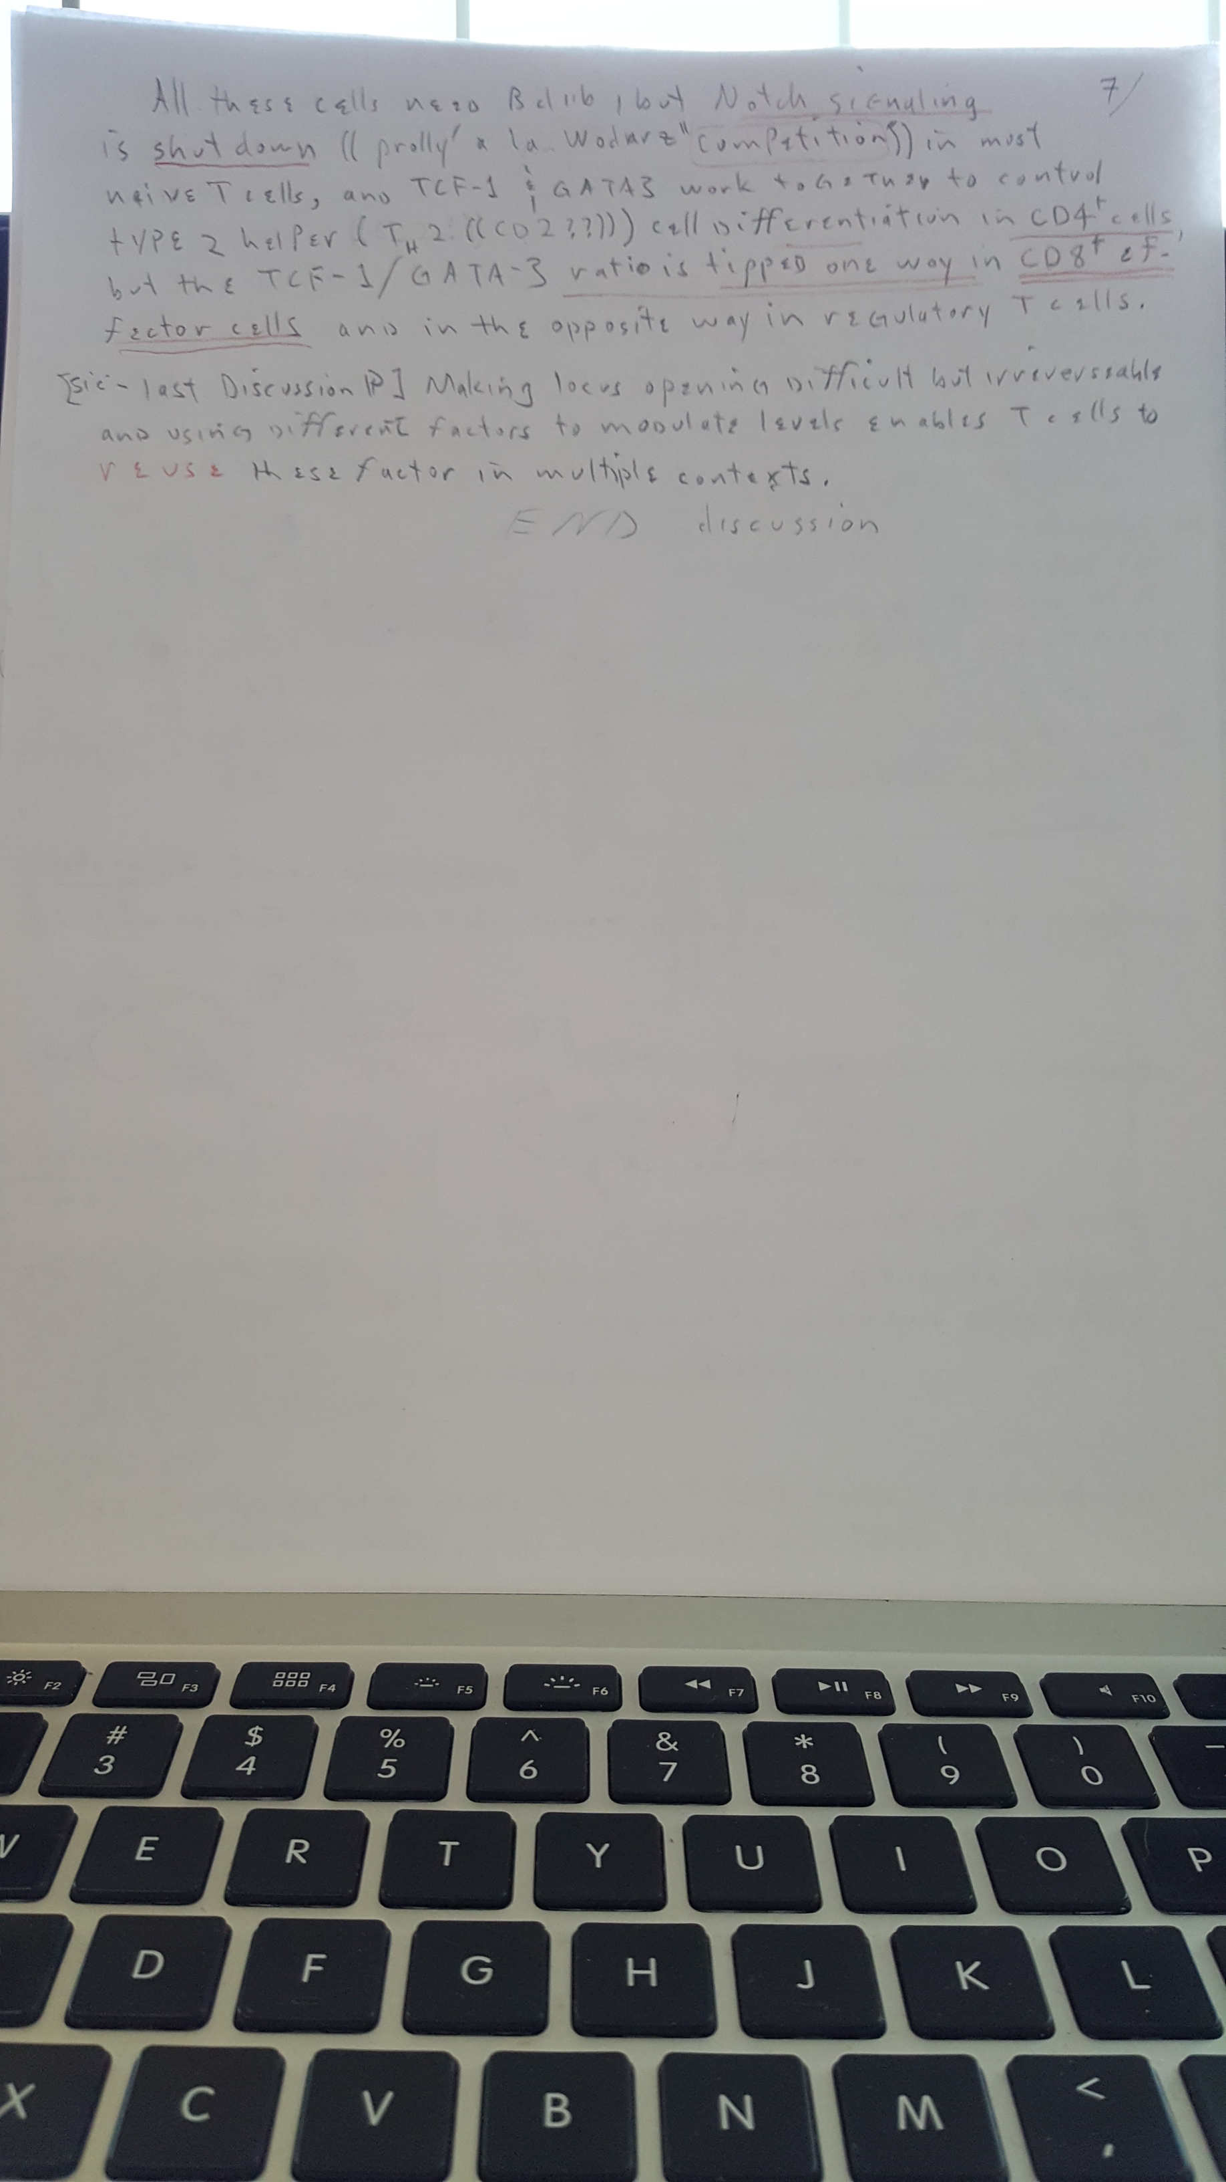

**FOLLOW UP ON;**

**Kueh(2) Citation # 13 (“computations”)**

**.**

https://www.ncbi.nlm.nih.gov/pmc/articles/PMC3565808/

https://www.ncbi.nlm.nih.gov/pmc/articles/PMC3565808/

////////////////////////////

//////////////////////////////////

///////////////////////////////////////

Computational modelling of T-cell formation kinetics: output regulated by initial proliferation-linked deferral of developmental competence

**Erica Manesso,**1 Vijay Chickarmane,2 **Hao Yuan Kueh,2** Ellen V. Rothenberg,2 and Carsten Peterson1

https://www.ncbi.nlm.nih.gov/pmc/ ≫>

https://www.ncbi.nlm.nih.gov/pmc/articles/PMC3565808/

````````` snippets ````````````` cp/paste

abstract;

While substantial progress has been made to delineate the developmental pathway of T-cell lineage commitment, still little is known about the relationship between differentiation competence and the remarkable expansion of the earliest (DN1 stage) T-cell progenitors. T

we developed computational models where the probability to progress to the next stage (DN2) is related to division number

 To satisfy differentiation kinetics and overall cell yield data, our models require that adult DN1 cells divide multiple times before becoming competent to progress into DN2 stage.

Our findings were subsequently tested by *in vitro* experiments, where putative early and later-stage DN1 progenitors from the thymus were purified and their progression into DN2 was measured.

These experiments showed that the two DN1 sub-populations divided with similar rates, but progressed to the DN2 stage with different rates, thus providing experimental evidence that DN1 cells increase their commitment probability in a **cell-intrinsic manne**r as they undergo cell division. Proliferation-linked shifts in eligibility of DN1 cells to undergo specification thus control kinetics of T-cell generation.

The logistic equation for the smooth curve Kueh_2 pg961 Fig5d) can not be proven by me.

f(t) = A / {1 + exp[ 4v(t – τ) / A]}

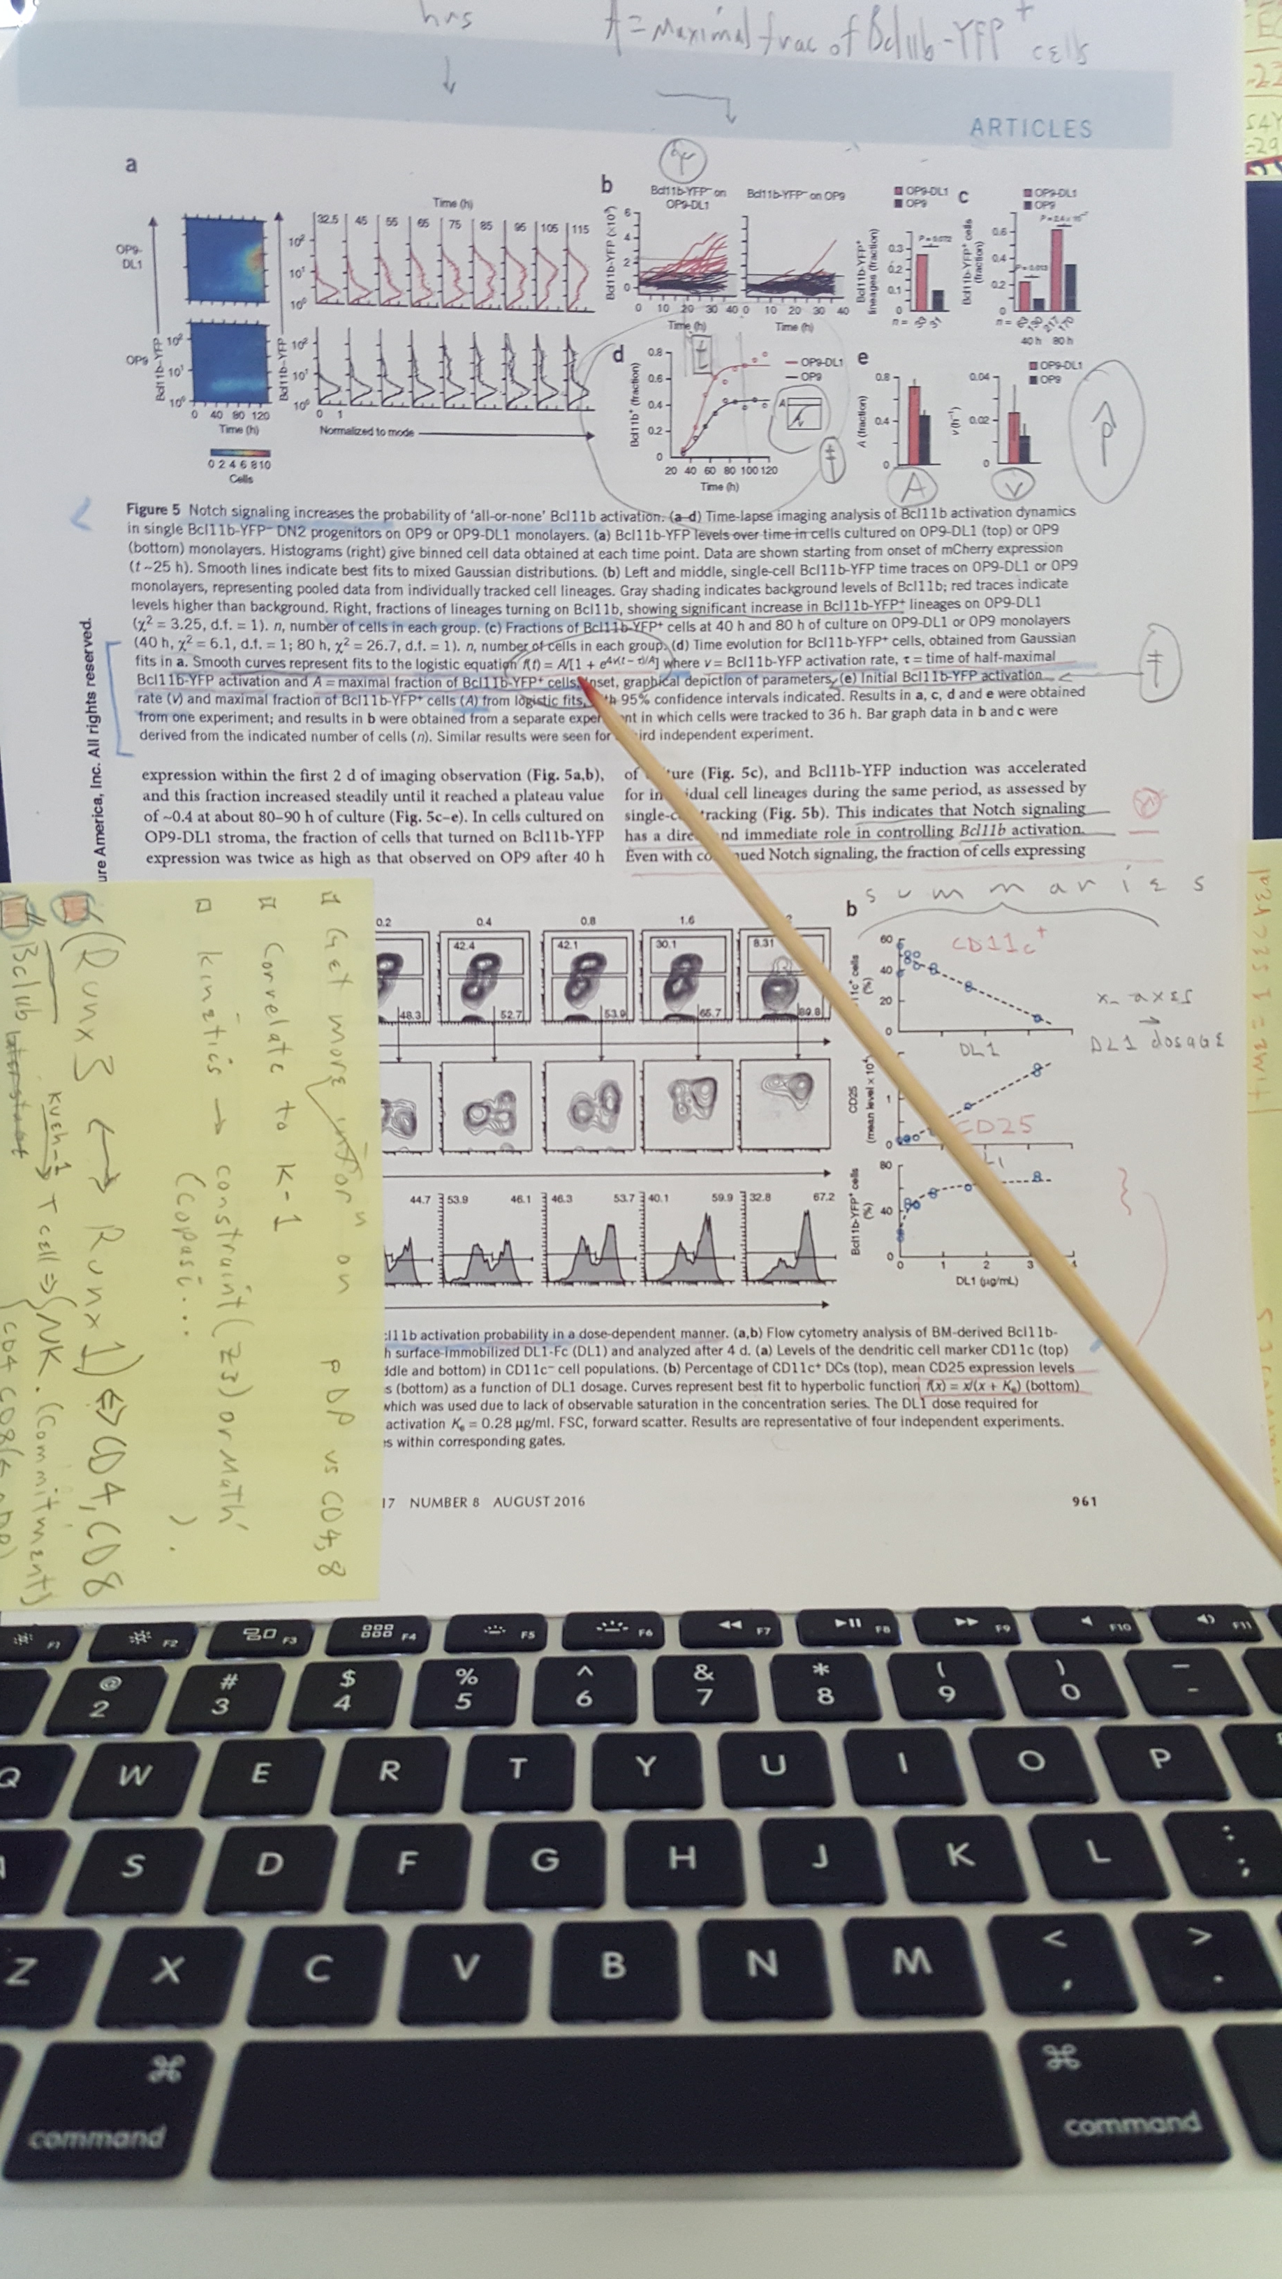

Since confirmation of the abo ve equation cannot be met, it’s noted that the domain time, that for (newly named..) CTL-dyn_7. will use a probability P = 0.7 for Bcl11b activation. K-2 (Kueh_2) pg61 (961) histogram Fig 5e shows [sic] maximal fraction (p^) for ;

A ≈ 0.7 .

It’s also noted this is not the mean since the Fig5a) explanation refers to “A = **maximal** fraction of Bcl11b+ cells”.

KUEH _ 2

///////////////////////////////also REFER TO HAND WRITTEN NOTES ON “KUEH 2”///////////////////////////////////

KUEH _ 2

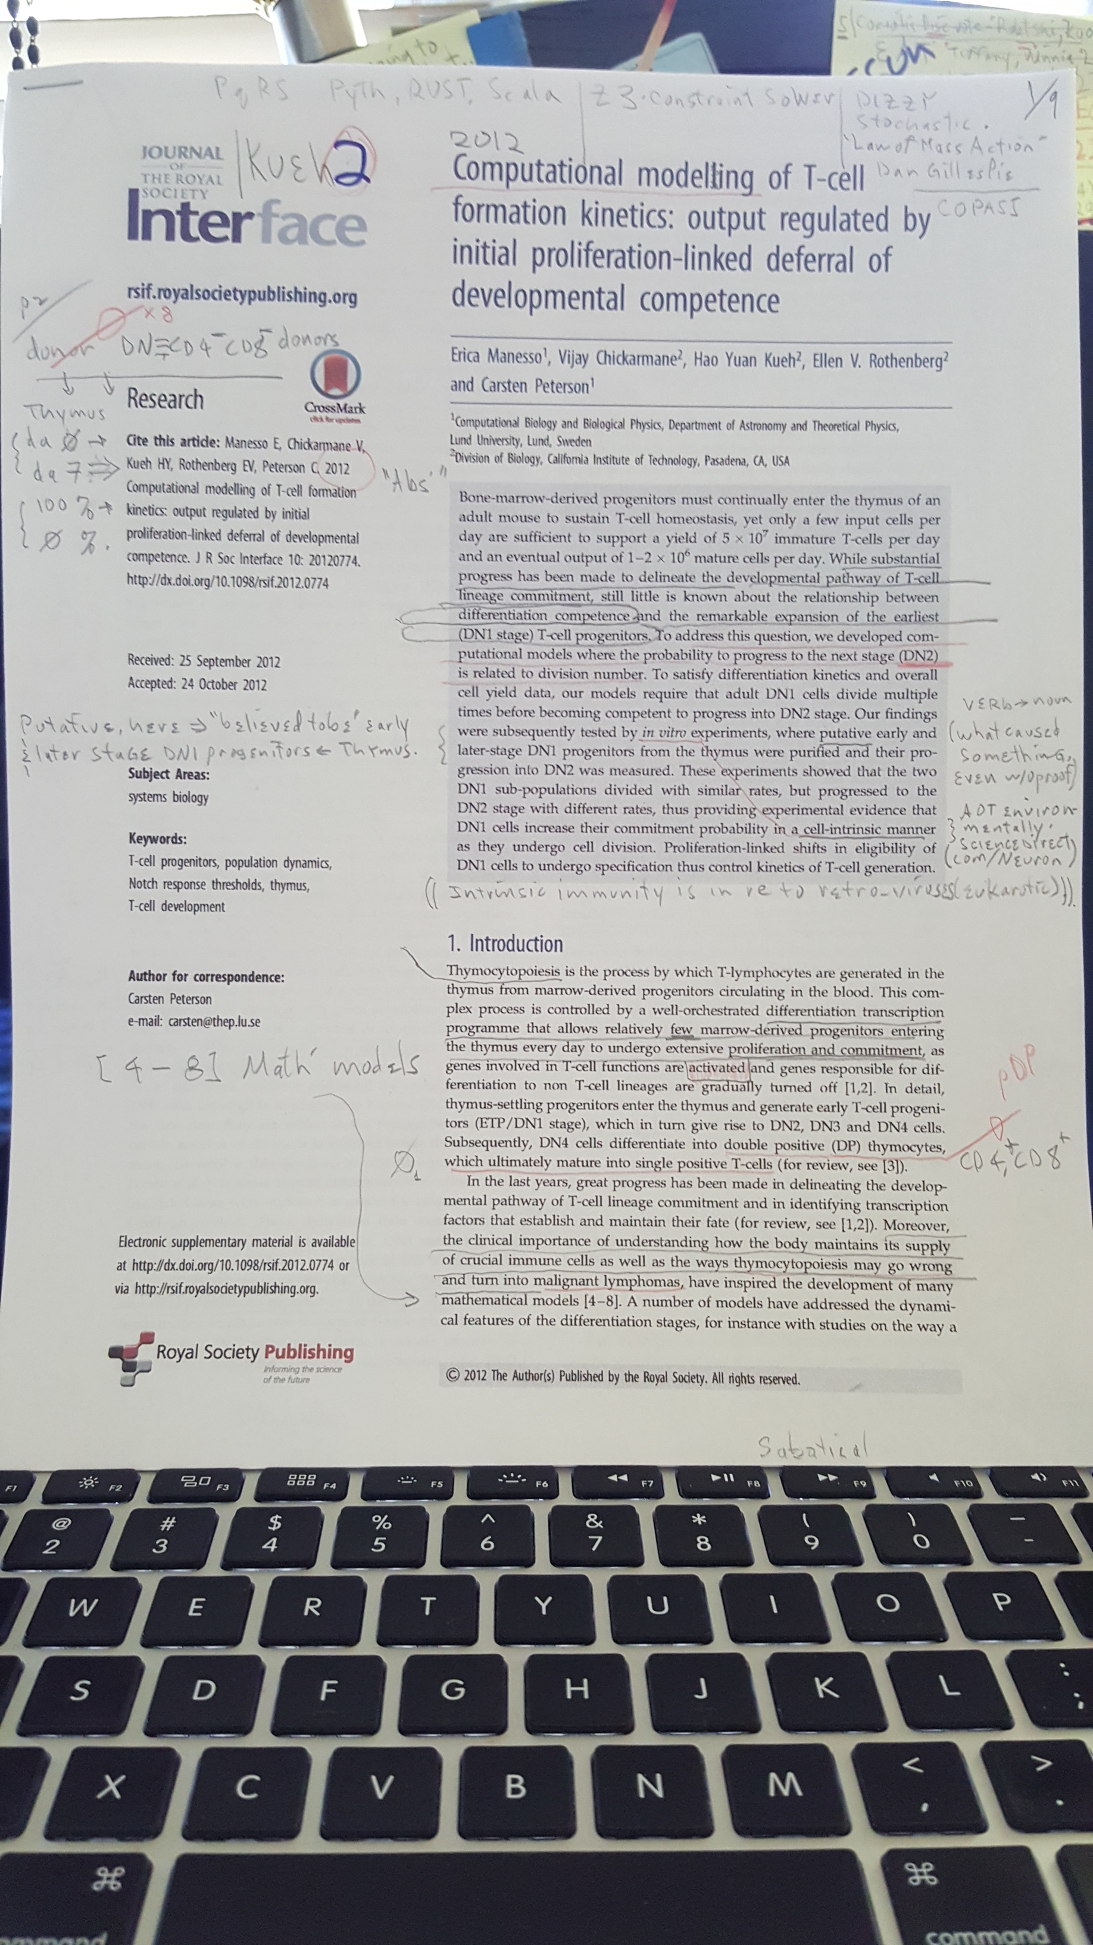

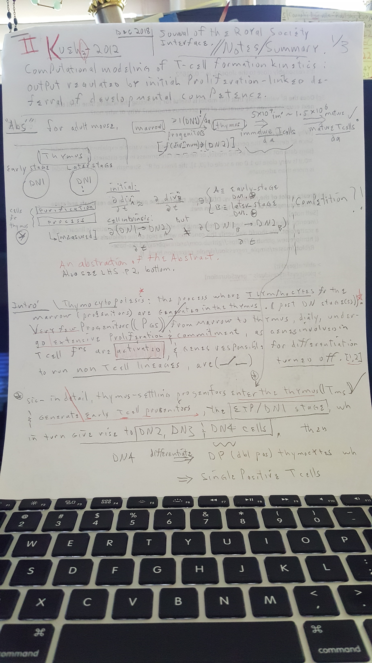

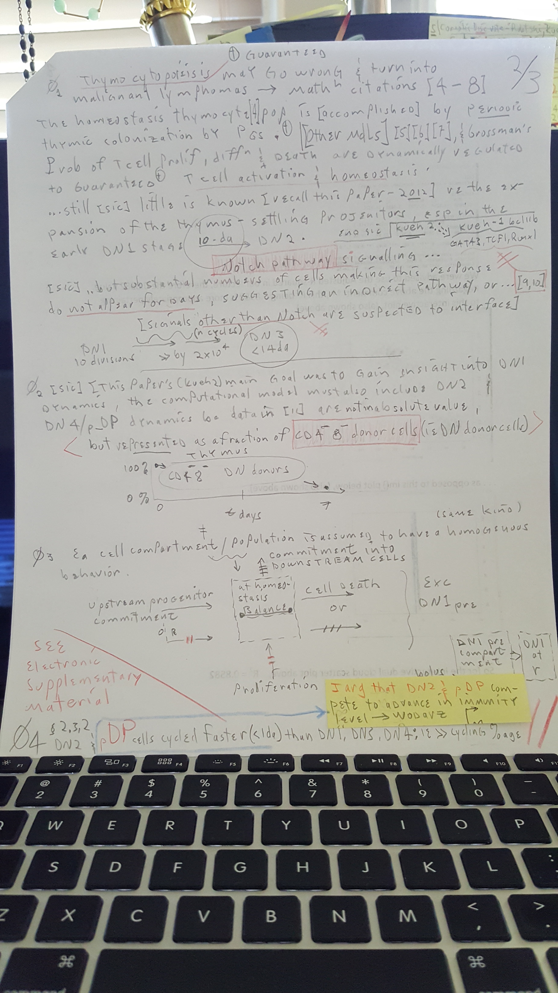

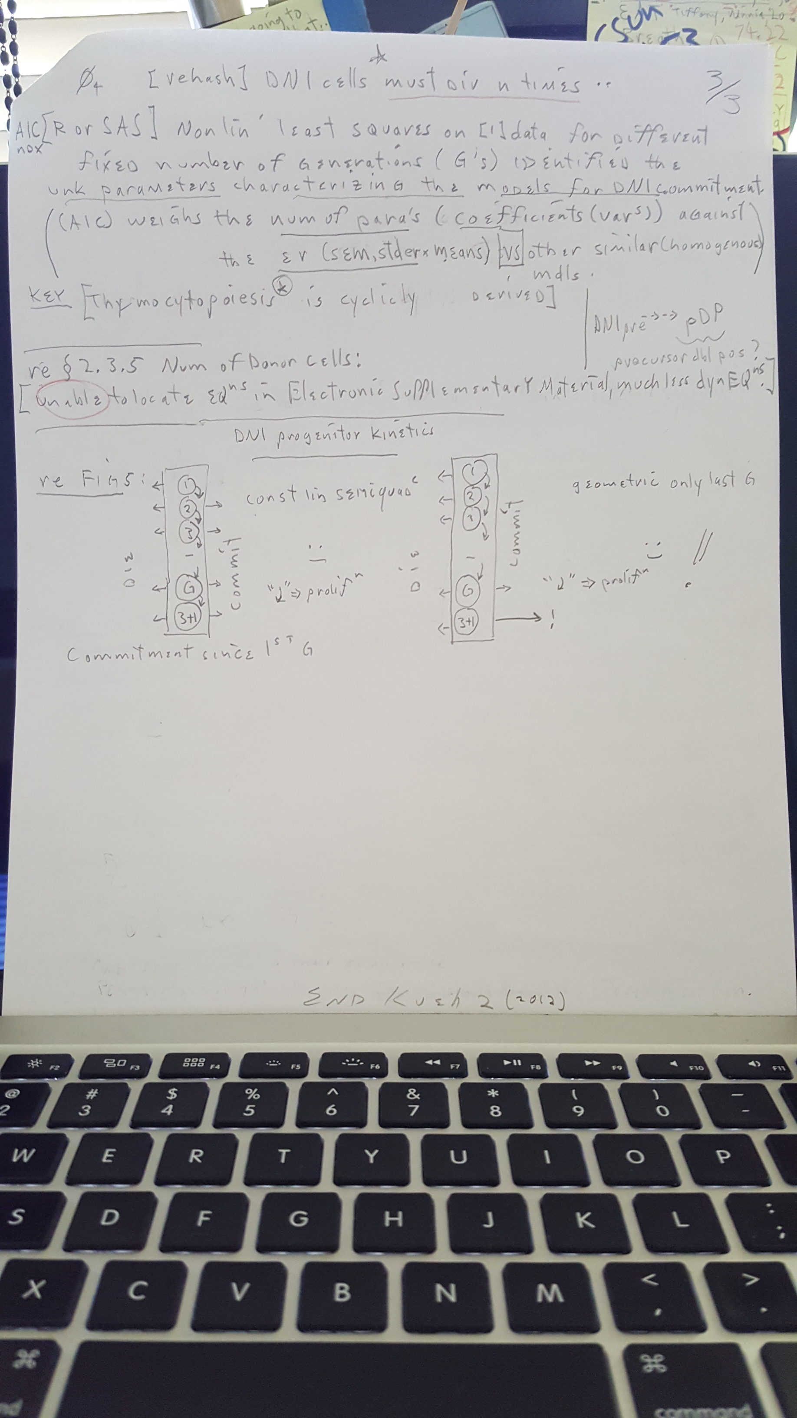

12-28-18

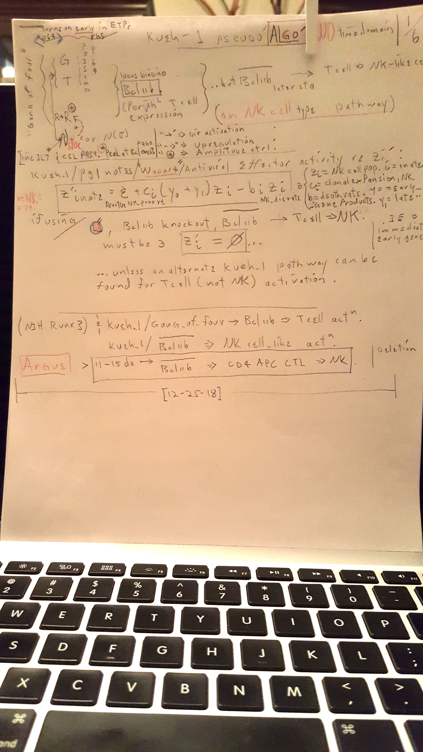

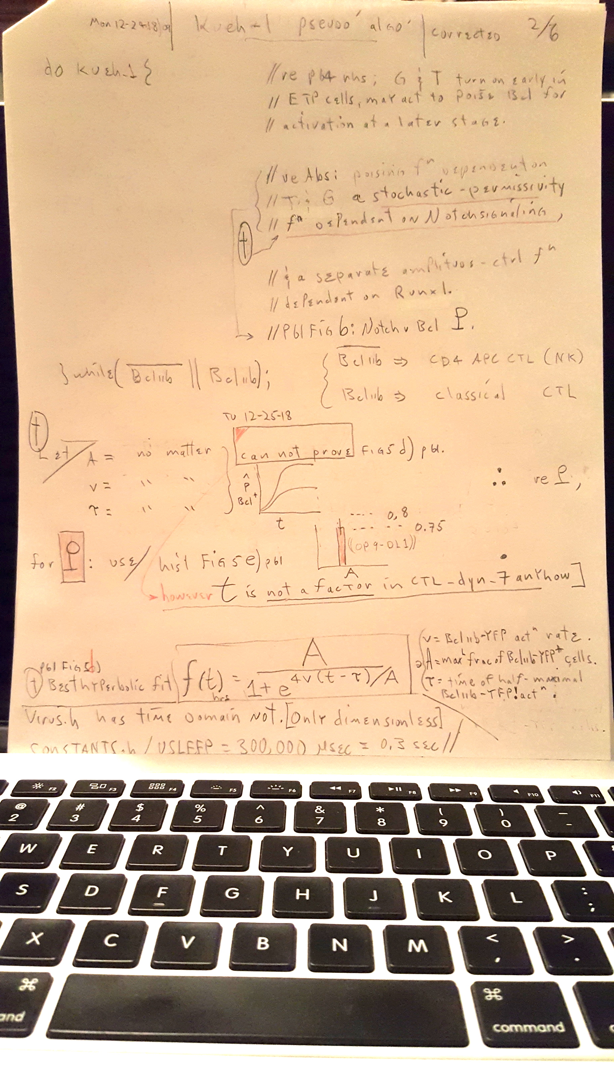

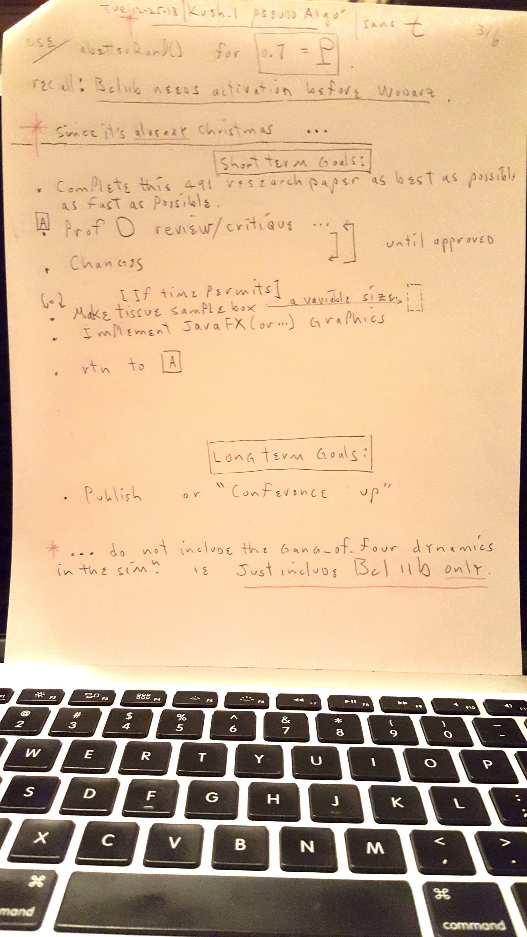

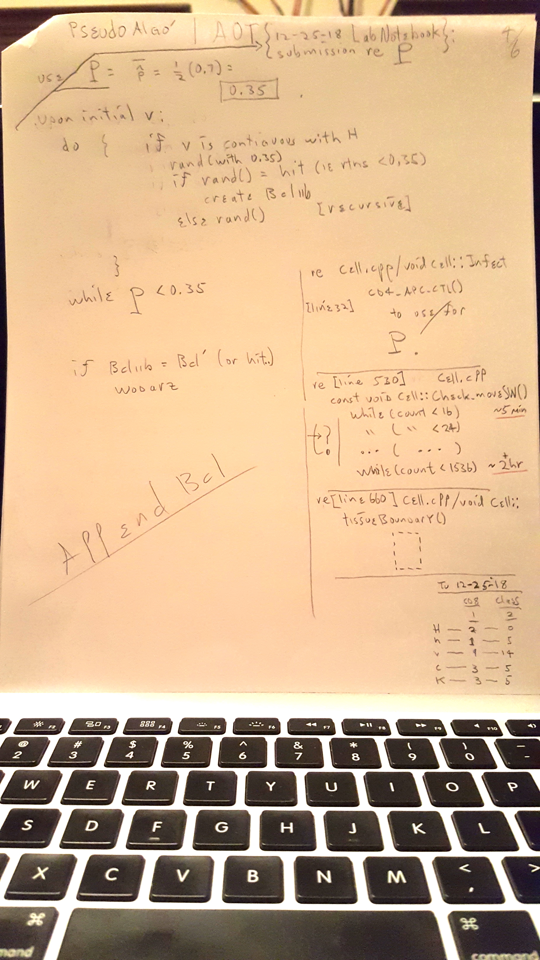

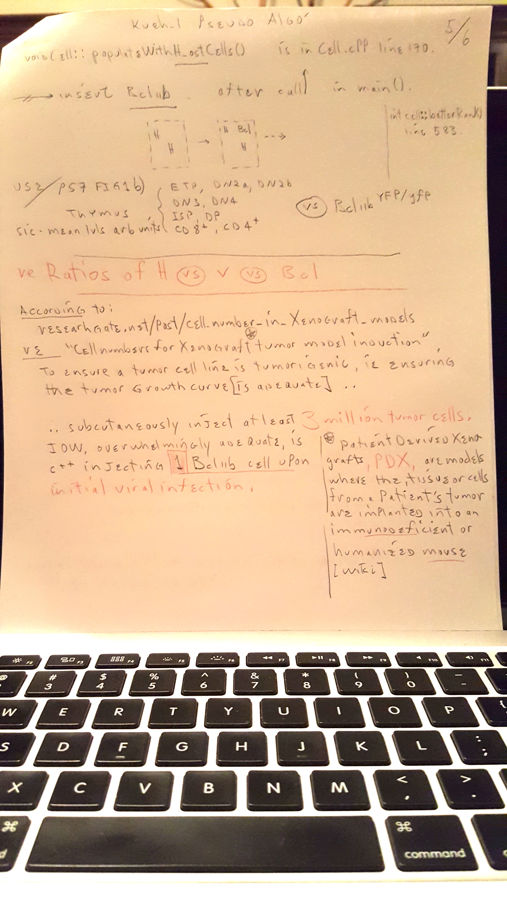

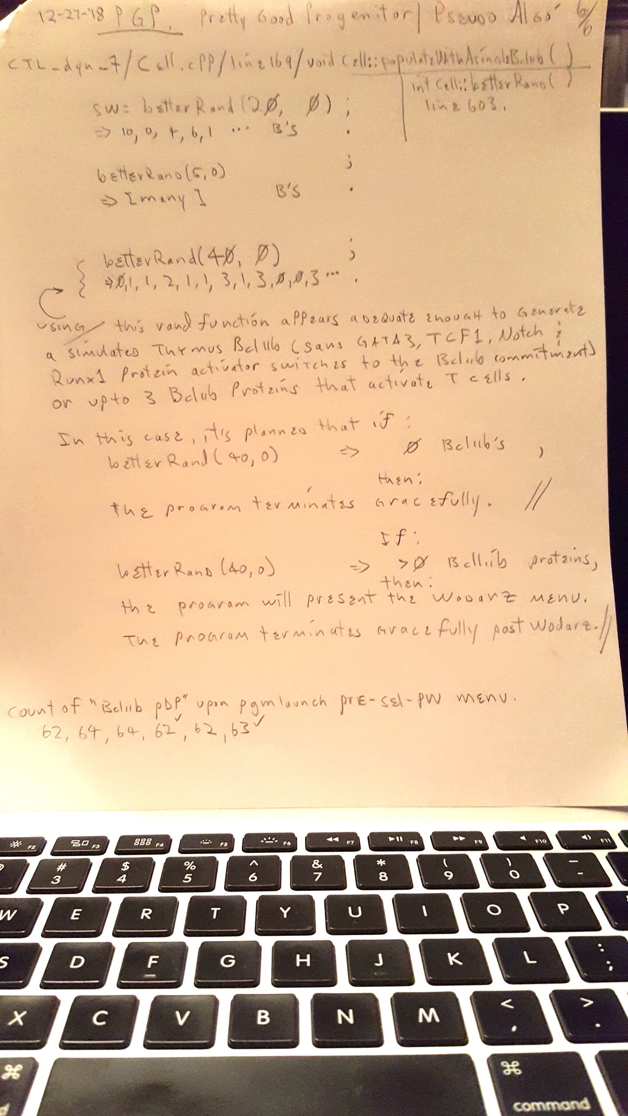

2-2-19 Happy New Year

Rather than heading down Extreme Blvd, (and sans any perceived laziness) I opted to not include the DN (double negative) (super)precursors (of committed T cells) in the sim’. I believe that it would have been very uneventful since they are literally switch-like genes anyhow. These switches of course play a very important role in Bcl11b gene thymocytogenisis. It’s helpful I think to see what’s going on before the Bcl thymocytes, but there would be too much clutter and minutia knowing that the sole intent was what was given in the presentation and the abstract of the paper, ie;

Derive a Wodarz – Kueh correlation.

The original concept shown in the presentation was –

**“CTL Dynamics: Insights into a Single Plausible Mathematically Driven Simulation of T-cell**

**Activation, Derived from Two Independent Research Papers.”**

The .ppt slide #6 graphically showed; Mathematical Correlations → Wodarz – Kueh Correlation Model.

This is true, but in a very simplistic view. The Bcl11b gene is represented by a probability by way of a special kind of random function. Upon success, the Bcl is recognized, thus simply enabling the Wodarz pathways to be present. If Bcl(11b) is not successful, the Wodarz algorithm does not nor can not exist. **ie the patient’s life will expire, unfortunately.**

The program and sim(ulation) as it is today, works correctly. Cleaning up and “beautifying” it will be next. Adding graphics or CGI would be very nice. I think this would be a new project however. Java-FX would be my choice of graphics library if I decided to do that.

2-3-19)1016

Once, upon launching runtime with

CTL_dyn_8

a sample tissue depiction contained a ‘B’ (Bcl11b), meaning the pgm should continue with Wodarz.

It gracefully HALTED, thinking there were NO BCL’s. Obviously, there was ONE Bcl11b gene.

A user msg indicating [NO BCL] was printed. This is incorrect.

Bad.

//////////////////////////////

On another pass, this occurred;

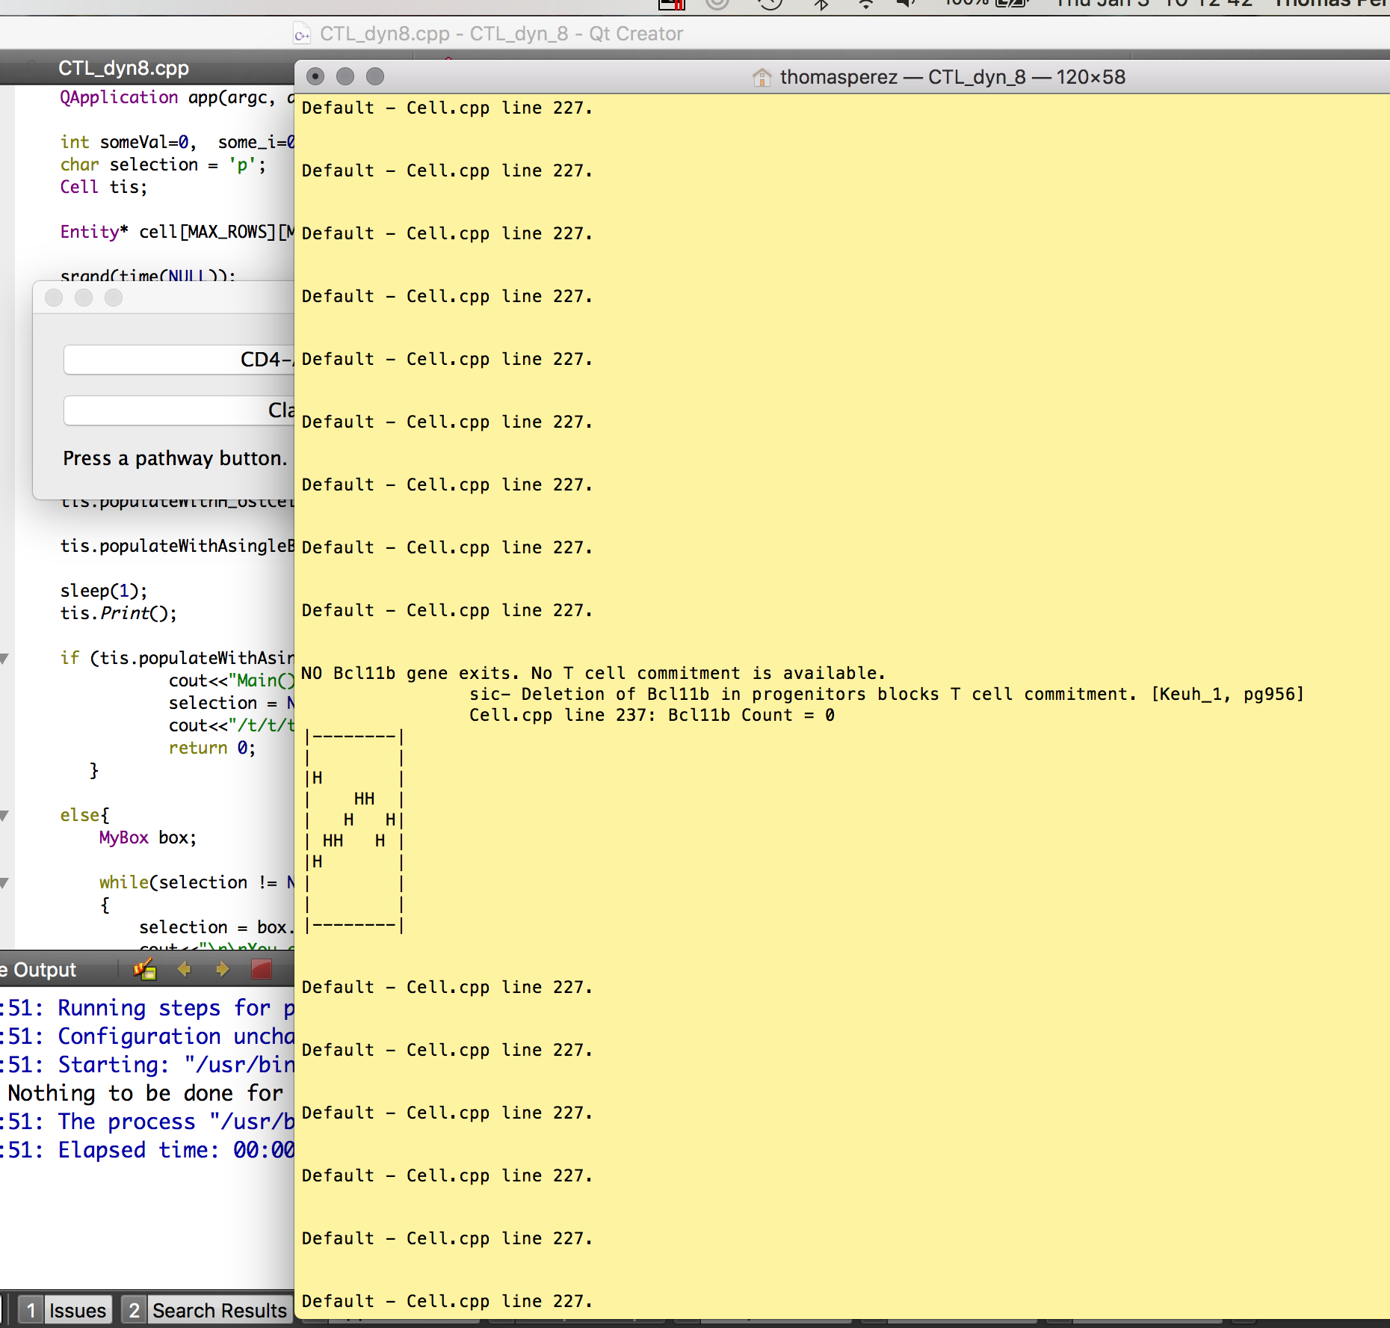

Bad.

//////////////////////////////////

//////////////////////////////////

It’s believed that at least ONE problem may conceivably be data racing b/t

a) Print(), and

b) populateWithAsingleBcl11b() .

A sleep() function is known to not be professional. Testing continues.

///////////////////////////////////////////////////////////////////////////////////////

Once bugs are snuffed, it would be nice to have

a) variable tissue size,

b) H_ost and v_irus counts

c) et al

changeable by the user.

/////////////////////////////////////////////////////////////

1-4-19)1320

Bugs resolved. No sleep() needed.

More console o/p transparency is implemented by way of changes in main() and Cell.cpp.

Tissue depictions with initial Host cells is complete.

Tissue depictions with Bcl11b is complete. Wodarz pathways continue.

Tissue depictions sans Bcl11b alerts the user that [no T cell commitment is available and is fatal]

..of course no Wodarz pathway can continue, so the program gracefully terminates.

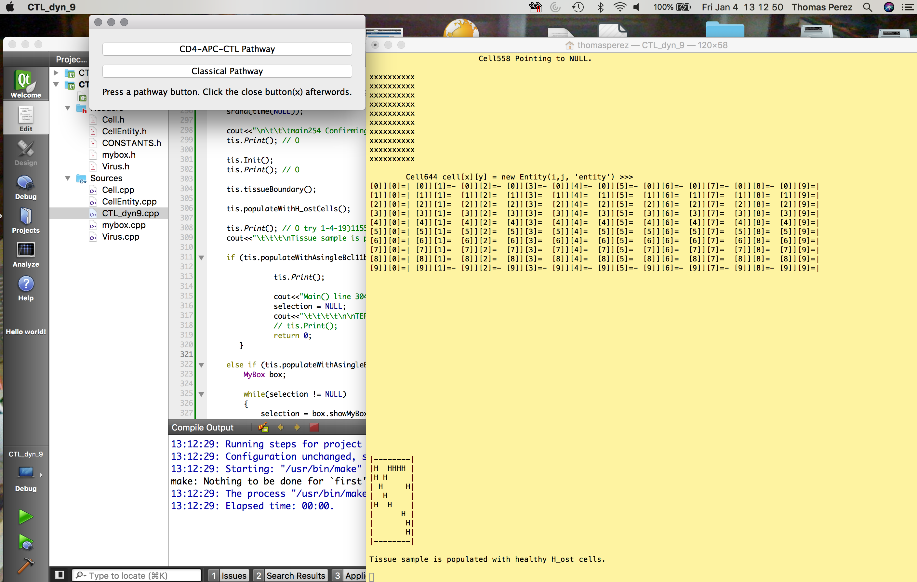

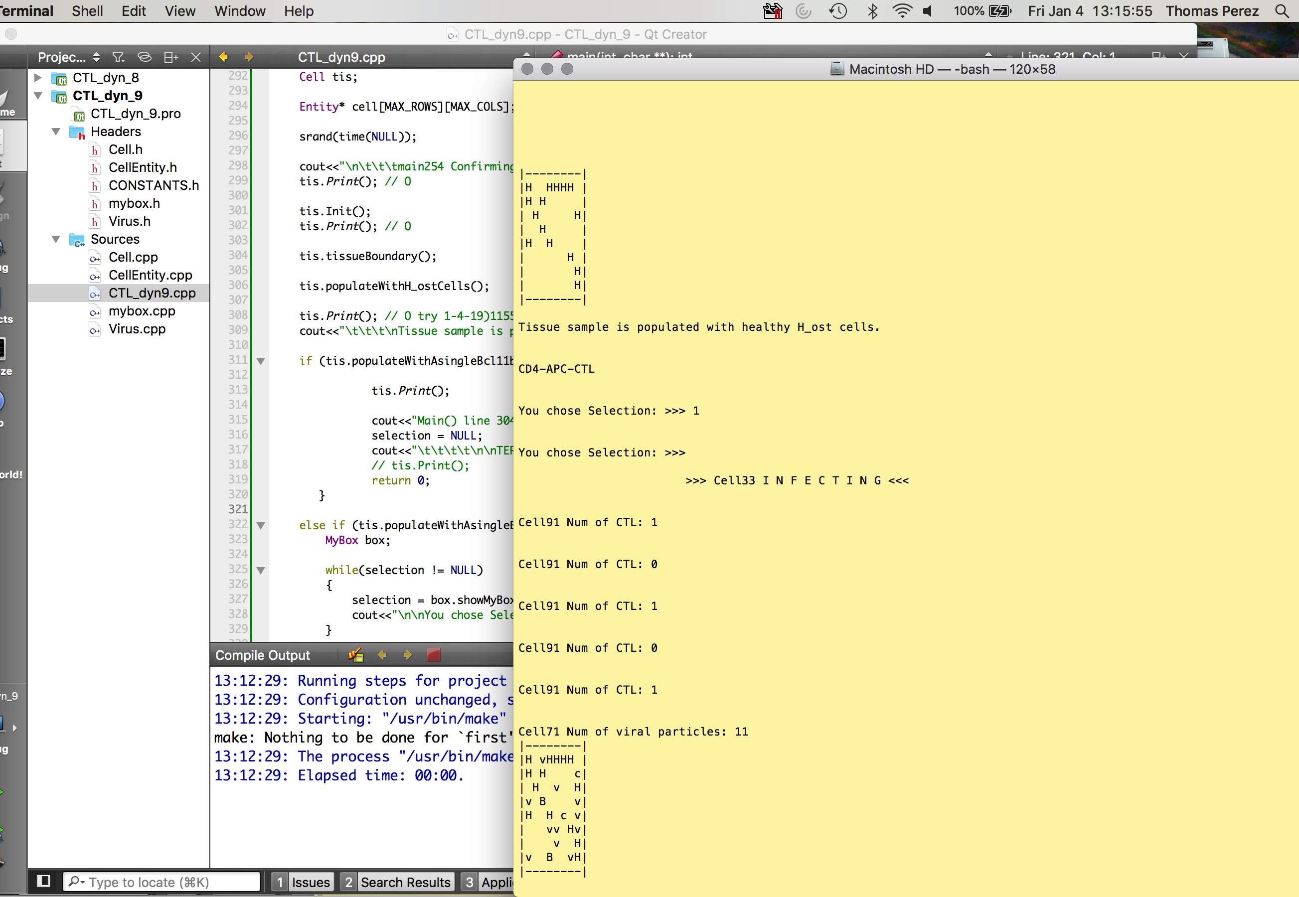

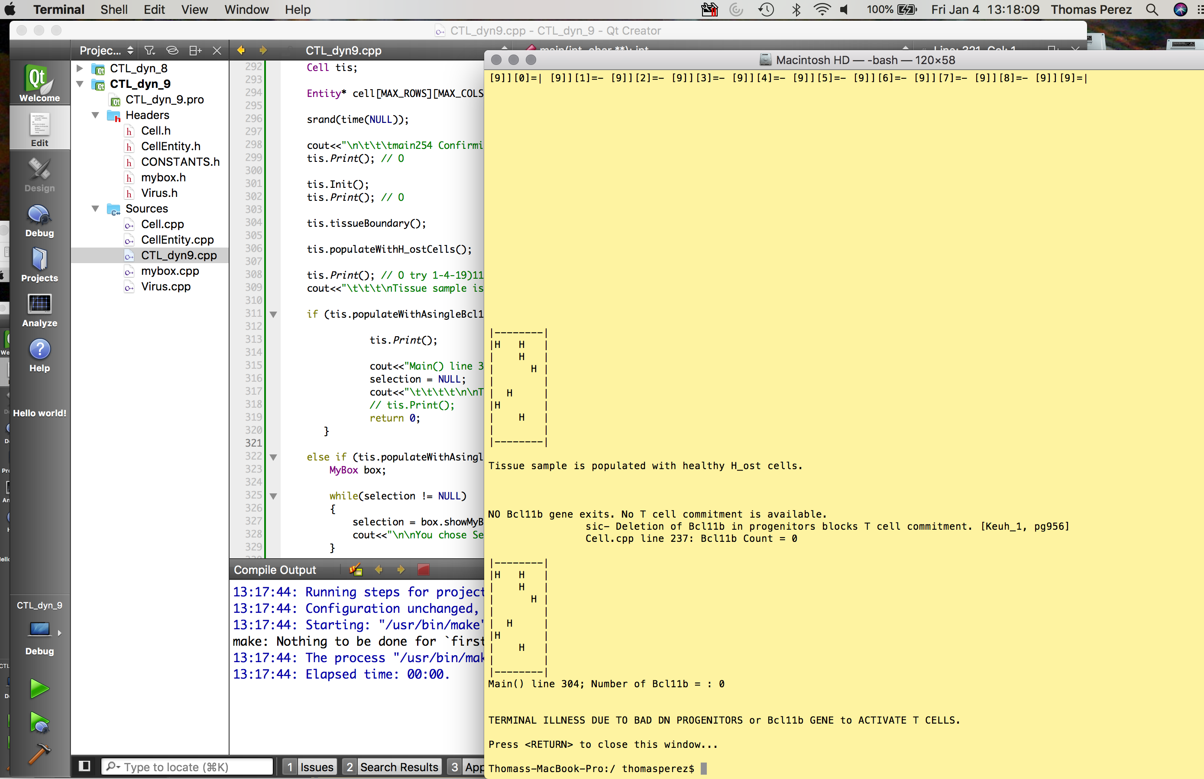

1-6-19)0915

It’s believed that assuming the project, CTL_dyn_9 is complete as it stands today, it may behoove me

to start with writing a

**post-rough-draft of the paper.**

Upon completion of the phases of these, towards a

**“camera-ready”** version of the paper, I’ll commence of course with the

**final draft,** then the

**final paper submission.**

I believe that I’ll use the professor’s papers;

a) On Data Structure, via Constraint Logic Programming

b) Automated Data Structure Refuting Common Wisdom

as examples.

1-21-19

In regards to the 2-2-19 log entry in red, an elaboration is useful. According to several instances in Kueh_1 (“Asynchronous Combinatorial Action of Four Regulatory Factors of T Cell Commitment”, ie the 1st or main paper read and researched), depending on the development of the DN cells, Bcl11b may or may not be present. If present, they can and will activate T cells.

My argument is that Wodarz then comes into play. Upon satisfactory Bcl11b commitment, the Wodarz dual-pathway scenario comes into action. This paragraph is a sidenote.

My main focus of today’s entry is the following. As mentioned in Kueh_1, and (again) elsewhere, paragraph one of the main body;

“[Bcl11b] deletion at later stages **can** cause T cells to become natural killer (NK)-**like**” cells10.”

Key words are “can” and “like”. The former is of course noncommittal, and the latter is a noncertainty.

The portion of the algorithm is up for debate, however, Kueh has a strong fundamental argument that without Bcl11b, T cell commitment (in general) is not possible. The algorithm was written as follows;

. . .

Bcl11b →CD4-APC-CTL (ie NK)

}while (!Bcl11b || Bcl11b);

Bcl11b → classical CTL

However I argue that upon serious infections, NK must be present and robust. Therefore CTL_dyn_9 is designed such that iff Bcl11b is present, then and only then will Wodarz T cell pathways playout (“come into focus”, in Android OS terms).

1st DAY OF SPRING 2019

1-22-19

--------------------------------------------------------------------------------------

Michael ≫> CSUN symposium application due by ;

Feb 1st. Must do presentation for > C in class. [not SDPS sr des proj symp]

APRIl 5th 2019 is presentation day.

csun.edu/research-graduate-studies/csunposium (sp)

Abstracts due next Tues < 1159pm. 150 words.

3 or 10 min talk or poster

1-24-19

CSUNposium ≫>

re Sched of Events Fri 4-6-19

BELOW; somewhat tentative;;;;;;;;;;;;;;;;;;;;;;;;;;;;;;;;;;;;

?try to apply for 10 min / Session 15, College of CECS – 12:20 (also avail for 0830AM)?

with Check-in Pkg pickup at 0800 US Tujunga.

Pkg pickup at 0800 ‼

THEY WILL TELL YOU , after they get and accept your abstract, what DAY and what time you’re

talk will be in.

////////////////////////////////////////////////////////////////////////////////////

/////////// BACKUP of MAIN() comment (intro’ to sim) partially complete 1-24-19)1200

//MAIN.cpp

// CTL_dyn_9

// Thomas E. Perez Spr 2019 | COMP491 research project | with Prof Kyle Dewey PhD

/**

********************************************************************************************

* *

* KUEH - WODARZ CORRELATION MODEL *

* *

* Refer to COMP491 research paper *

* *

* *

* *

********************************************************************************************

> PLEASE REFER TO CTL_dyn_9-postRoughDraft.docx (Tue 1-22-19) FOR DETAILS.

> Possible CASE_USE STUDY and DETAILED FEASIBILITY REQUIREMENTS TBA.

[The following refers only to Wodarz dual pathway T cell commitment, and not Kueh T cell commitment research.]

[For my Wodarz-Kueh T cell commitment correlation model, please refer to CTL_dyn_9-postRoughDraft.docx (Tue 1-22-19) FOR DETAILS.]

[Publishing of this is TBA.]

Other than the system requirements brief, a "nuts and bolts" quick synopsis of this project is this;

According to Dominik Woodarz, in his book;

"NK Cell Dynamics - A Mathematical and Computational Approach to Immunology",

he presents two theories in the beginning, and expounds on those to extrapolate other theories as well

and explains those initial fundamental theories for a more precise vision of NK (natural killer)Cell Dynamics,

and how we are able (or not) to recover from serious viral infections. His experiments were done through out many

years with a research staff with mice and monkeys, and mainly the virus LCMV,

(lymphocytic choriomeningitis virus. LCMV is of a cancer type, and is ideal for the study of cancer and

its behavior and intricacies.

The two theories his two pathways, because of the pathology that CTL (Cytotoxic T-cell Lymphocyte) may take,

one way or the other, to fight the infection. The two pathways are;

CD4_APC_CTL Pathway, and the

Classical Pathway.

The algorithm derived from Wodarz stochastic linear equations are simplified down to probabilities. The probabilities are generated

via a special type of random function. Other than his degrees of freedom that are inherent in his equation sets, these are the only

Wodarz probabilities provided. Please recall, for simple linear equations, degrees of freedom means;

dimension (ie number of coefficients (or variables)) - number_of_constraints (ie num of independent equations)

ie, if you have ;

x + 2x = 5

x/3 + 9x = 7

2x + 4x = 10, (a linear combination),

there are only two constraints since the 3rd equation is a multiple of the 1st. The dimension = 2 as well. This is a square matrix,

which is good, making for an adequate unique solution.

The greater the number of equations relative to the number of unknowns, the greater the overdetermination is, which is bad, so there

may not be any solution. The converse would turn out to be what's called underdetermination, eg if you have only

one equation with >> 1.

Discussing the Wodarz pathways follows.

Firstly,

using the Wodarz (et al) CD4_APC_CTL Pathway, (cytokines (a signaling protein);

viz IL2 (interleukin-2)), a simulation is represented here using a sample tissue mass with susceptible tissue cells to infection.

H_ost cells (the cap 'H' means the H_ost cell is not infected yet), a small 'h' means it was just infected or is infected),

v_irus particles ('v's), and CTL white blood cells ('c's) all play roles in this simulation.

The new (Kueh) model includes the Bcl11b gene, activated by four proteins in which the gene may provide T cell commitment.

"APC activation" is the principle mechanism for this CD4_APC_CTL Pathway, and is a linear model.

Secondly,

the Classical Pathway is a nonlinear one.

In the Classical Pathway scenario, CD40 + CD40L pair, or B7 + CD28 (and other CD pairs) pair (or possibly both pairs

suggested by some), is(are) a signaling process(es), as a product of an immune response, and hopefully virus clearance.

In passing, when mentioning 'virus', cancer is a virus type, but unique in evolution. ie the typical cancer cell is a retrovirus,

Therefore, the following terms for this research are interchangeable;

Virus,

Retrovirus,

Cancer.

A frame by frame depiction of H_ost cell vs h_ost cell vs c_TL vs v_irus vs K (Killer cell) will be displayed via of

an IDE console output. As of 1-2-19 (very recently compared to the inception of my first endeavor, (Wodarz modelling)),

what is introduced as a completely and separately researched ambition by a professor,Hao Kueh from Caltech is a gene

called Bcl11b. He and his team published a paper that explains non-mathematically, (as opposed to professor Domink Wodarz

from UC Irvine, even though Kueh et al shows probabilities of Double Negative progenitors towards the development of the

Bcl11b gene in great detail), the activation of the Bcl11b gene by 4 proteins. His earlier work, (cited in my research

paper (post 1-2-19)) was in regard to the evolution of the Bcl11b gene. According to his research T cell activation

does not exist without Bcl11b. As explained in my research, I argue that there must be a correlation between the vastly

differing "philosophies" regarding T cell activation. This correlation is depicted via the previously mentioned IDE

frame by frame output.

A quick legend explanation to the IDE output is warranted;

If a (healthy) H-ost cell becomes infected, it turns into a small 'h'. If a virus, 'v' comes in contiguous to a H-ost

cell via natural migration (special random function), the 'H' becomes 'h'. If and when a virus gets k_illed (K) by a

CTL ('c'), the 'v' becomes a 'K'.

Proximity is also the mechanism for this lysis ("poisoning" the virus to death (classical pathway)), as opposed to

apoptosis (a programmed dismantling of the virus particle, a la (CD4 APC CTL pathway) ) to occur.

A white space or spaces (char ' ' or char * ' '), within the boundary is the remaining sample tissue.

It is not susceptible to infection. The tissue which contains healthy cells, virus particles, infected cells,

white blood cells (lymphocytes (CTL->NK cells)) are the only entities resident in this organ.

To summarize the symbology;

H = (healthy) H_ost cell

h = infected h_ost

v = virus or virus particle

c = CTL/NK (natural killer) cell

K = killed (the virus is killed)

[Again, the frame by frame cell movement depiction is reminiscent of an animated sketch book with each page having

a drawing of some animated object performing some motion. (Flipping through the book from page 1 to page n makes

the animation or person do something in realtime.)]

----------------------------------------------------------------------------------------------------------------|

Initially, the vulnerable tissue sample will healthy H_ost cells, randomly.

|--------|

| H |

| H |

|H H |

| H |

| H H |

| |

| H |

| H |

|--------|

Actually, prior to the "Initially" part above almost invariably, the Bcl11b gene will be present to activate

T cell progenitors in the infant spinal cord. These will be represented by 'B'. If none exist, the individual will

become a patient, unfortunately.

|--------|

|B H |

| H |

|H H |

| H |

| H H |

| B |

| H |

| H |

|--------|

>>>> Assuming Bcl11b exists (sans robustness factors), the program continues >>>>>

>>>

>>>

In this case; v=virus cells, H=healthy H_ost cells and c_TL migrate. Also v infects then (hopefully) c proliferates.

..to a lesser extent, Bcl11b proliferates.

|--------|

|vBc H v|

|v H c |

|H vH |

| v H v|

| H c H v|

| v vB v |

| H v c |

|cvHv v v|

|--------|

A v "next" to a H turns the H into an h. Hopefully a v will be killed by a K. This

means that not only was Bcl11b

present initially, but the Wodarz pathway for NK cell action came into play.

|--------|

|v c H K |

| v B Kc |

| hv h h |

| v |

|h cH v |

| hvKKH K|

|B v cv|

|cKh K |

|--------|

Metrics:

[The remaining number of cells are listed after the last frame]

[END of frame by frame Wodarz-Kueh Correlation Model depiction.]

-----------------------------------------------------------------------------------|

Finally – an update to the Notebook ;

Possible connection [K]**→** [W]

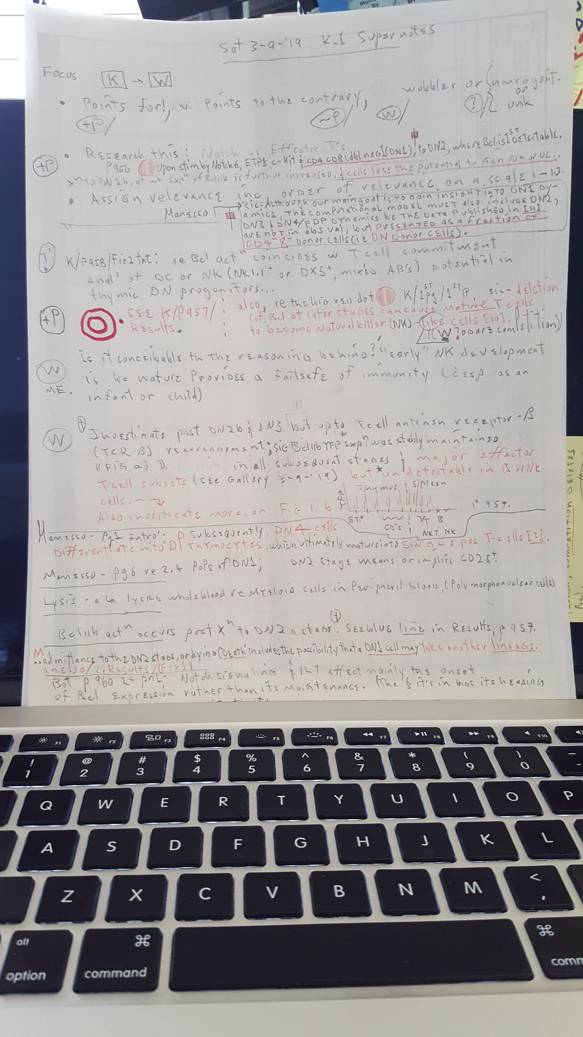

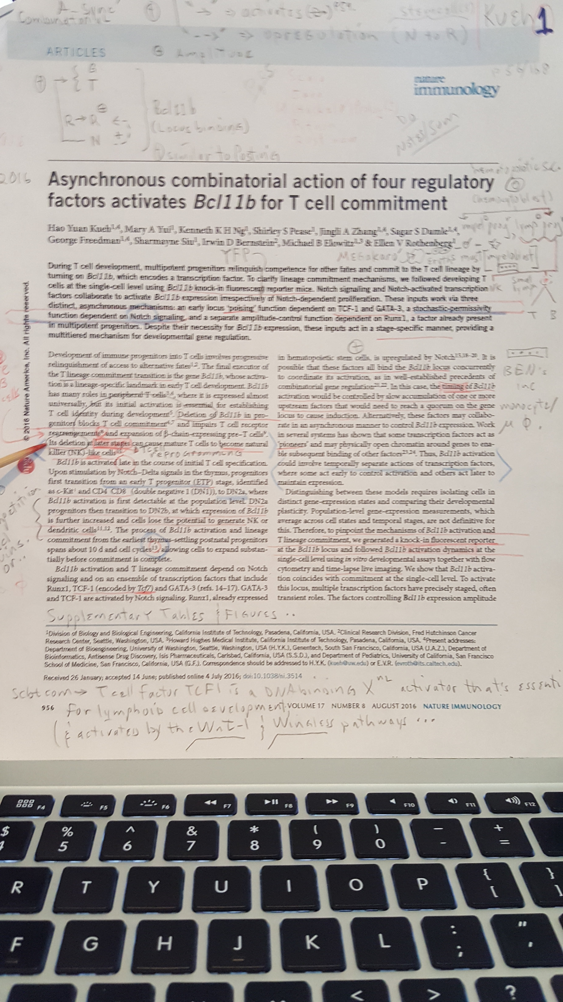

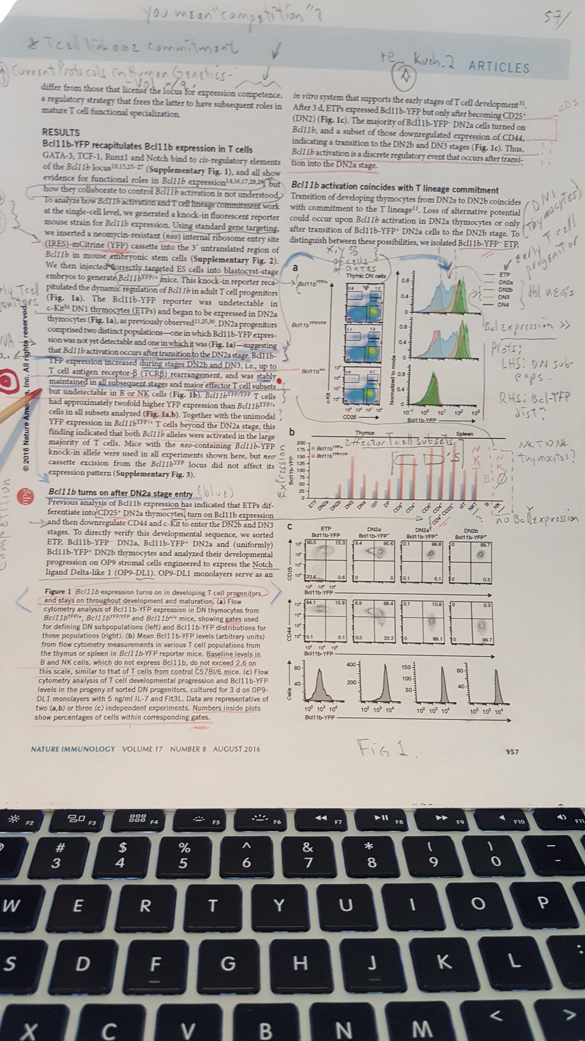

Re the connection of [K]**→** [W] ;

In the above jpg of page 956, (the 1st page of Kueh), it’s noted that;

sic – **Its (**re Bcl11b**) deletion at later stages can cause mature T cells to become natural killer (NK)-like cells.** end sic.

This, in relation to the 2nd page sentence under Results, which reads ;

sic-.. **and was (**re Bcl11b expression**) maintained in all subsequent stages and major effector T cell subsets but undetectable in B or NK cells.** end sic.

The former tells me that it is possible that mature T cells can conceivably become NK or sic - NK-like cells, true, but via at least another mechanism that can include the Wodarz pathways. This implies that Wodarz competition will eventually be controlling as required by the immune response.

Regarding the latter, sans viral or serious viral infection, the immune system, viz most T cells at least, will have Bcl11b protein. It’s conceivable that it (Bcl11b fluorescent Pt) is undetectable in B or Nk cells because only Wodarz has control of it at this point. Wodarz comes into the picture upon antigenic stimulation, so the “undetectable” part is valid upon antigenic stimulation.

End Mon 3-11-19